Deploy the Java App to Oracle Cloud Infrastructure (OCI)

Introduction
In this activity, you’ll deploy the same Spring Boot + MySQL “Orders App” used in previous lessons in CST-323. This time we will deploy to Oracle Cloud Infrastructure (OCI) but with a few key differences.
Platform as a Service
Where AWS, Azure and Google Coud platforms emphasize Platform as a Service (PaaS) deployment models (e.g., AWS Elastic Beanstalk, Azure App Service and App Engine), Oracle’s ecosystem remains closer to Infrastructure as a Service (IaaS). This means that rather than simply pushing your app to a managed environment, developers must first design the underlying network. Developers must create a Virtual Cloud Network (VCN), gateways, subnets, and firewall rules before deploying compute or containerized services on top.
This architecture reflects Oracle’s heritage in enterprise data systems integration. OCI is designed for customers who need tight network control, private routing, and hybrid connectivity with on-site data centers. That’s why you’ll experience a deeper look “under the hood” of cloud infrastructure in this lesson.
Compare Four Cloud Service
Feature | AWS | Azure | Google Cloud | Oracle Cloud (OCI)
Main PaaS Service | Elastic Beanstalk | App Service | App Engine | Primarily Compute Instances / Container Instances (IaaS)
Deployment Model | PaaS (abstracts infrastructure) | PaaS (managed runtime) | PaaS (serverless option) | IaaS-first (requires VCN + subnet setup)
Container Hosting Option | ECS / EKS (Elastic Container Service / Kubernetes) | Azure Container Apps / AKS (Kubernetes Service) | Cloud Run / GKE (Kubernetes Engine) | OCI Container Instances / OKE (Kubernetes Engine)
Database Integration | RDS (MySQL) | Azure Database for MySQL | Cloud SQL (MySQL) | OCI MySQL Database Service
Networking Abstraction | Managed by Elastic Beanstalk or ECS; minimal manual setup | Managed by App Service or AKS; optional VNet integration | Fully managed; networking transparent | Manual creation of VCN, subnets, gateways, security lists required
Ease of Deployment | Push app via AWS CLI or Elastic Beanstalk UI; auto-provisions | Deploy from GitHub or Azure CLI; auto-scaling built-in | Simple gcloud app deploy; least setup effort | Requires manual provisioning of compute, MySQL, and container networking
Scaling & Load Balancing | Auto Scaling Groups + Elastic Load Balancer | Auto-scale via App Service Plan | Auto-scales automatically (App Engine Standard) | Manual configuration or use of Load Balancer Service
Cost Model | Pay-as-you-go; billed by instance-hours and storage | Pay-as-you-go; App Service Plan tiers | Pay-as-you-go; free tier for App Engine Standard | Pay-as-you-go; fine-grained compute pricing but setup overhead
Unique Strength | Deep ecosystem, strong DevOps integration | Excellent Visual Studio / GitHub integration | Simplest deployment flow; auto-scaling by default | Tight network control & enterprise security features
Best Use Case | Standard PaaS apps, auto-scaling APIs | Web apps integrated with Microsoft stack | Rapid student deploys / auto-scaled APIs | Hybrid enterprise systems & custom network design
Containers
Another major difference in this tutorial is that you will deploy the application using containers. OCI’s Container Instances service runs your Docker image pulled from Oracle Container Registry (OCIR). This method is faster, lighter, and easier to replicate than manually configuring a virtual machine.

Learning Objectives
After completing this lesson, you will be able to:
- Compare Oracle Cloud’s IaaS approach to the PaaS-oriented deployment models used in AWS, Google Cloud, and Azure.
- Create and configure a Virtual Cloud Network (VCN) with gateways, subnets, and firewall (Security List) rules to enable secure communication between compute and database services.
- Provision and connect to an Oracle MySQL Database Service (MDS) running inside a private subnet.
- Build and containerize a Spring Boot application using Docker, and push the image to Oracle Container Registry (OCIR).
- Deploy the Orders app to Oracle Container Instances, configuring environment variables and network rules to allow access from a browser and connectivity to the database.
- Diagnose and troubleshoot OCI network and container issues, including port access, route rules, and database connection errors.
- Evaluate the pros and cons of IaaS-style deployment versus PaaS-style deployment in cloud architecture design.

New Changes in This Version
Topic | Previous Lessons | Oracle Cloud Version (New)
Deployment Model | PaaS (Elastic Beanstalk, App Engine, App Service) | IaaS-style networking + Container Instances
App Runtime | JAR file deployed directly to managed service | Docker container built locally and pushed to OCIR
Network Configuration | Mostly automated by cloud platform | Manual setup of VCN, gateways, route tables, and security lists
Database Connection | Publicly accessible MySQL instance | Private Oracle MDS with internal-only IP connectivity
Access Control | Auto-configured firewall rules | Manual ingress/egress rules for port 8080 (app) and 3306 (database)
Deployment Complexity | Streamlined, minimal networking setup | Hands-on infrastructure design—closer to real-world DevOps

Learning Goals
- Deploy a Java web app (Spring Boot) to Oracle Cloud Infrastructure (OCI).
- Create and configure an Oracle MySQL Database Service instance.
- Set up OCI Compute (VM or App Deployment) with the correct networking and environment variables.
- Connect the Java app to the Oracle MySQL instance using secure credentials.
- Understand deployment alternatives: Compute instance vs. Oracle App Platform vs. Container (OKE).

Prerequisites
- Oracle Cloud Free Tier or paid account.
- Java 17 or 21, Maven 3.9+ or Gradle 7+.
- The same working Spring Boot + MySQL app you deployed to AWS/GCP/Heroku.

Key Vocabulary
Term | Definition
Tenancy | Your root account in Oracle Cloud (contains all compartments, users, resources).
Compartment | A logical group for OCI resources including compute, database, and network.
VCN (Virtual Cloud Network) | Your private cloud network in OCI, similar to a VPC in AWS.
Subnet | Subdivision of a VCN where your VM or app runs.
Shape | Defines CPU/memory for compute instances (e.g., VM.Standard.E4.Flex).
OCI CLI | Command-line tool for provisioning and managing OCI resources.
MySQL Database Service (MDS) | Managed MySQL compatible with standard JDBC URLs.
App Deployment / Stack | Prebuilt templates that automate compute, storage, and networking.

Part A — Environment Setup
- Read the Oracle tier options and sign up for the free tier.
https://www.oracle.com/cloud/free/

How Oracle Cloud Free Tier works
- Start with a US$300 cloud credit.
You’ll have 30 days to use it to test your applications on all OCI services, in addition to Always Free Services in your Free Tier account.
- At any time during or after the 30-day period, switch to a Pay As You Go account. Pay only for services that exceed the monthly free amounts from Always Free Services.
- If you do nothing after 30 days, you’ll continue to get Always Free Services in your Free Tier account.
Create a new user account. You will need a valid email address, a credit card and a mobile phone to complete the signup process.
- Sign in to the Oracle Cloud Console
Go to https://cloud.oracle.com and log in with your credentials.
- Set your region
Choose a region near your users (e.g., US-Phoenix-1, US-Ashburn-1).
- Create a Compartment
  - Navigate to Identity & Security → Compartments
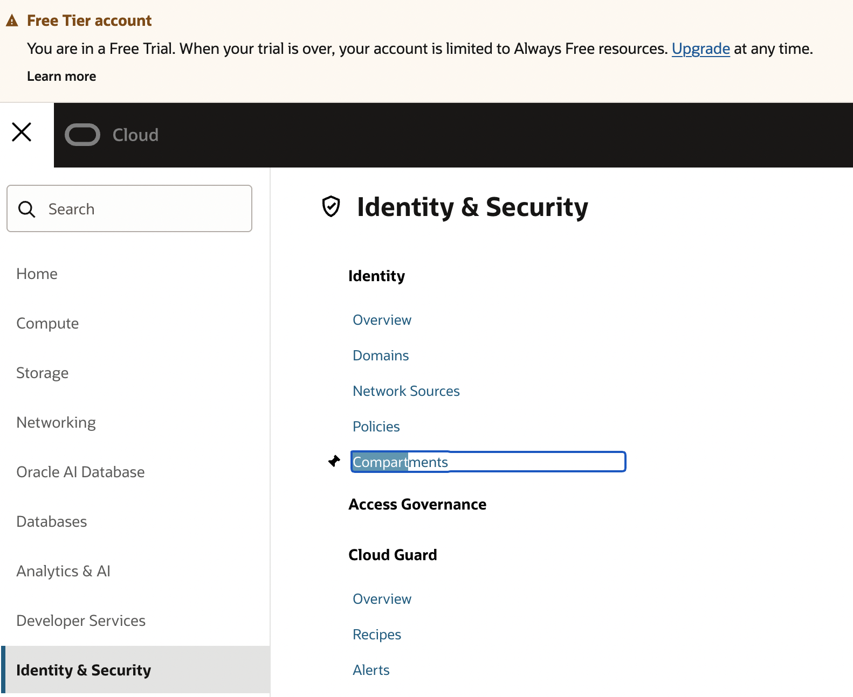
Figure 1 Location of "Compartments"
  - Click Create Compartment.
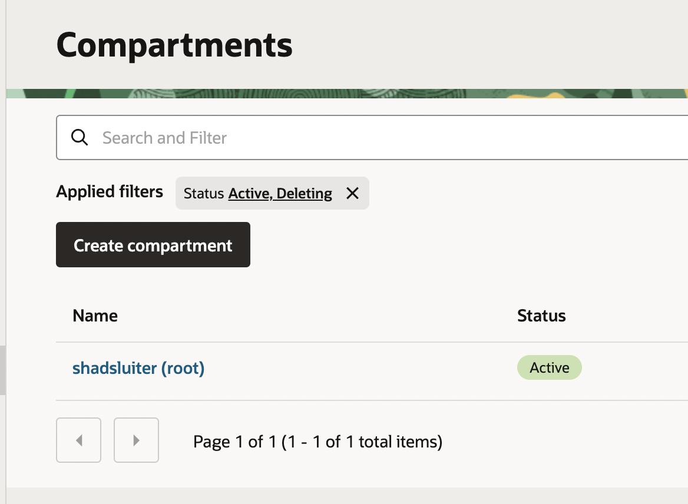
Figure 2 Creating a new Compartment
- Name the compartment cst329JavaApp or something similar.
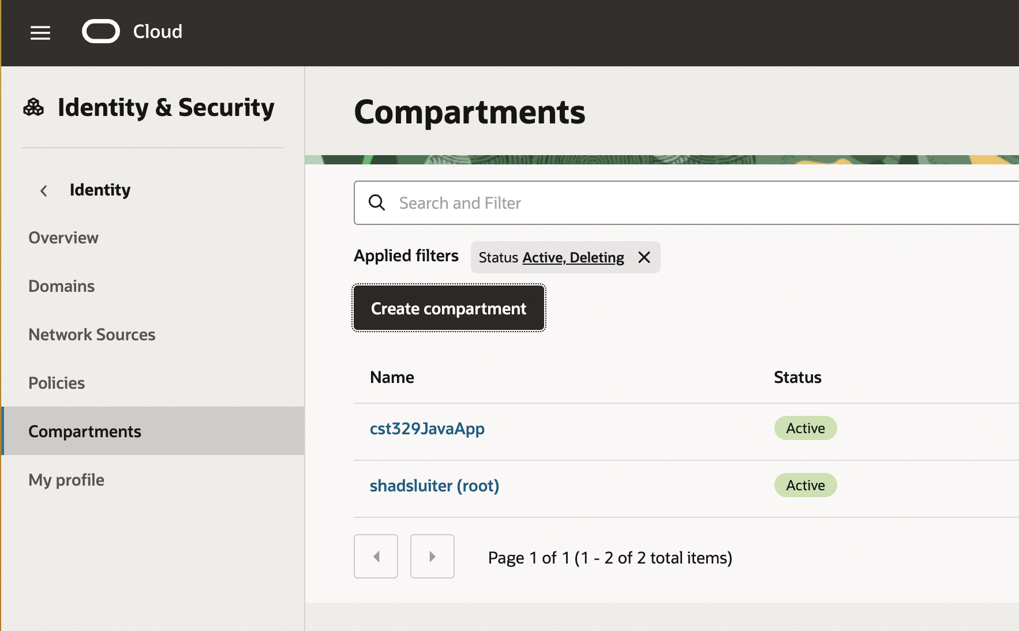
Figure 3 New compartment has been created and is listed

Oracle Command Line Tool
Oracle provides two main tools often confused by name: a mobile app and a command line tool for Windows or Mac.

1. Oracle Cloud Console App (Mobile)
- A phone app for iOS and Android.
- It lets you monitor and manage resources with commands such as restart an instance, check usage, and view alerts.
- You can find it in app stores under “Oracle Cloud Infrastructure Mobile App.”

2. OCI CLI (Command-Line Interface)
- A command-line tool for Windows, macOS, and Linux.
- This application is used to create compute instances, configure networking, upload files, and automate deployments. It is similar to AWS CLI or gcloud.

Install Instructions for OCI CLI
The CLI has both a Mac/Linux version as well as one for Windows. You choose only the version that applies to your computer.

Option 1 — macOS / Linux (Skip to option 2 for Windows)

  - Open the terminal application.
  - Copy and paste the following line.

curl -L https://raw.githubusercontent.com/oracle/oci-cli/master/scripts/install/install.sh | bash
  - Press Enter for defaults.
  - When finished type this at the command prompt to verify the installation is complete.
oci --version
  - Should print something like: 3.40.1.
  - If you get command not found, it’s probably a PATH problem:
Screenshot 1: “OCI CLI installed successfully.”
- Show the terminal output of oci --version.
- Caption: “OCI CLI installed and working on my system.”

- Take a screen shot of current status.
- Paste the image into a Word document.
- Put a caption below the image explaining what is being demonstrated.

Further steps if “oci not found” error.

Fix PATH for zsh (default macOS shell)

You may experience a path error because the installer adds the path to ~/.bash_profile, but the terminal zsh reads ~/.zshrc or ~/.zprofile.

Type the following command.

echo 'export PATH="$HOME/bin:$PATH"' >> ~/.zshrc
- What it does:
Adds a new line to your zsh configuration file (~/.zshrc) that tells your computer to look for programs inside your personal ~/bin folder first.
- Why it’s needed:
The OCI installer puts the oci command in ~/bin, but by default macOS’s zsh shell doesn’t look there when searching for programs.
Type the following command:

source ~/.zshrc
- What it does:
Reloads your shell configuration immediately, so the PATH change takes effect without restarting the terminal.
- Why it’s needed:
Without this, you’d have to close and reopen your terminal before the change takes effect.
Type the following command:

oci --version
- What it does:
Runs the oci command to confirm that it’s installed correctly and recognized in your PATH.
- Expected result:
You should see something like:
- 3.40.1

Option 2 — Windows (PowerShell)
Open PowerShell as Administrator and run:
Set-ExecutionPolicy RemoteSigned -Scope CurrentUser
iex "& { $(irm https://raw.githubusercontent.com/oracle/oci-cli/master/scripts/install/install.ps1) }"
After installation, verify:
oci --version
Then configure:
oci setup config
This creates your configuration file at:
C:\Users\<username>\.oci\config

Option 3 – Manual Environment Variable Settings
If your operating system blocks web scripts or PowerShell you can configure oci manually with the following steps.
- Download the latest oci-cli zip from GitHub:
https://github.com/oracle/oci-cli/releases
- Extract it manually (for example to C:\oci-cli).
- Add its bin folder to your PATH in the Windows Control Panel -> Environment Variables.
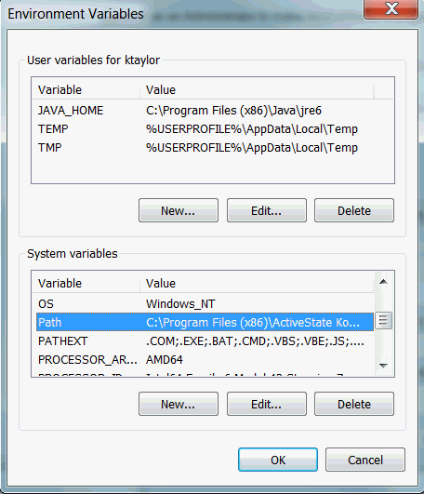
Figure 4 Example of a Windows computer setup for the PATH environment variable.

Verify Setup (both mac and Windows)
  - On your computer, verify that all necessary tools have been installed.
In the console, type these commands.
Java
java --version
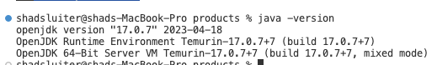
Figure 5 Successful message at command prompt indicating that Java v 17 is installed
Maven
mvn -v
Figure 6 Maven is installed. Version 3.9.7 is indicated in the message
Oracle Command Line Interface
oci -v
Figure 7 The Oracle Command Line interface (oci) is installed correctly.

Oracle Setup
Now that the software on your laptop is properly configured, it is time to setup resources on the Oracle Cloud. This will be done in the following phases:

- Setup Virtual Network
- Setup MySQL service
- Setup Java Container app.

Virtual Cloud Network (VCN)
A VCN (Virtual Cloud Network) in Oracle Cloud is your own private virtual network inside the cloud, complete with its own router, subnets, and firewall rules.
- In the Oracle console (web page), navigate to the Networking options.

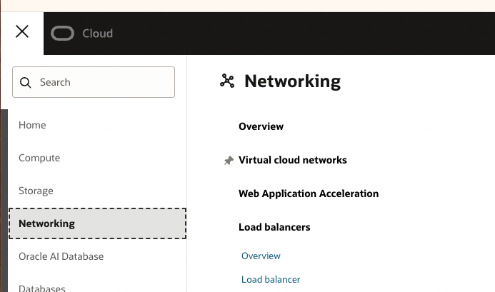
Figure 8 Location of the Networking options
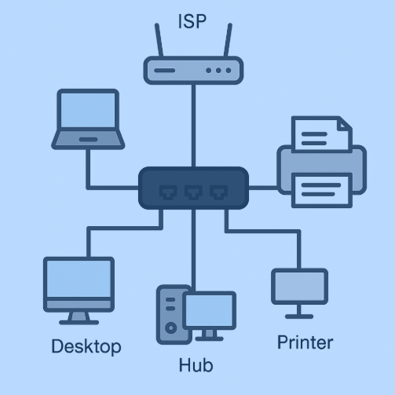
Figure 9 Figure of a home network with a router from the ISP and a local hub to serve multiple devices.

A Comparison with Home Network vs Oracle’s VCN
Every option in the Oracle virtual network is modeled after real world hardware. Refer to the following table to understand the terminology we are about to use. Previous knowledge of networks from “Introduction to Networking” or similar background is helpful in this section. If you need some background information, refer to these guides:

Guide to Network Devices

https://www.edupointbd.com/network-devices-ev/

Understanding IP addresses and subnets

https://www.digitalocean.com/community/tutorials/understanding-ip-addresses-subnets-and-cidr-notation-for-networking

Your Physical Network | Oracle Cloud Equivalent | What It Does
Physical network hub/switch | VCN | The overall network connecting all devices (VMs, DBs, etc.)
Physical Ethernet cables | Virtual Network Interfaces (VNICs) | How each resource “plugs in” to the network
Devices (computers, printers, NAS, router) | Compute Instances, Databases, Load Balancers – all virtual machines | The servers and services you create
Router or gateway to the internet | Internet Gateway (IGW) | Allows your VCN communicate with the outside internet
Wi-Fi SSID or subnet | Subnets (Public or Private) | Separate zones of your VCN; each has its own IP range
Firewall / NAT | Security Lists and Route Tables | Control traffic rules and routing inside/outside the network
Office LAN IPs (192.168.x.x) | Private CIDR (10.0.0.0/16) | Defines all the internal IP addresses your VCN can use

How It Works in the Cloud
Imagine Oracle Cloud giving you your own mini data center network, isolated from everyone else:

- The Internet Gateway is like the Ethernet cable from your office router to your ISP.
- The VCN is like your office’s internal network.
- The Subnets divide that space — some devices (web server) can be public, others (database) stay private.
- The Route Table has rules such as “traffic from 10.0.1.0/24 → internet goes through the IGW.”
- The Security Lists are your firewall rules controlling which ports are open while blocking others.

Real Example for Your Project
We will create a network and two subnets.
- VCN: 10.0.0.0/16
- Private Subnet: 10.0.1.0/24
- Public Subnet: 10.0.2.0/24
In each we will deploy the following:
- A MySQL Database in the Private Subnet
- A Compute Instance (Java app) in the Public Subnet
The two applications can talk privately via the internal network (10.0.x.x range),
but only the web app’s public IP is visible from outside.

Use the “Create a VCN” link

Figure 10 Location of Networking options
  - Select Virtual Cloud Networks
  - Click “Create VNC”
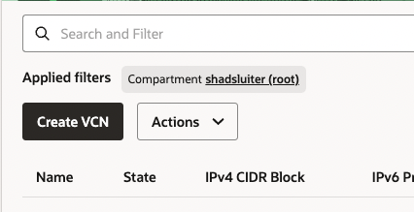
Figure 11 Create VCN button
This opens the VCN Wizard.
  - Choose “VCN with Internet Connectivity.”
  - Click Start VCN Wizard and follow the prompts:
- VCN Name: java-app-vcn
- Compartment: keep it as shadsluiter (root)
- IPv4 CIDR Block 10.0.0.0/16
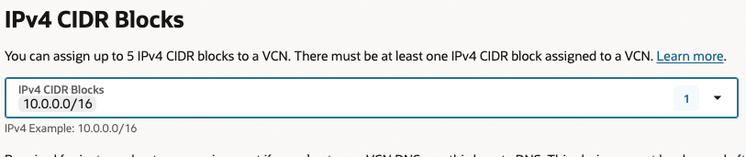
Figure 12 Assigning an IP address for the network.

Why 10.x.x.x?
The 10.0.0.0 – 10.255.255.255 range is part of the private IP space. That means:
- It’s not routable on the public internet.
- It’s meant for internal networking like your home Wi-Fi using 192.168.x.x.
The Oracle Cloud VCN can safely use these addresses without conflicting with the internet.

“Use DNS hostnames in this VCN”
Keep this ON (the blue toggle). This allows Oracle Cloud to assign internal hostnames like the following example.
myvm.subnetname.javaappvcn.oraclevcn.com
DNS is helpful later if your compute instance connects to the database by name instead of IP.

DNS Label
Type a short name with letters and numbers only (no spaces or underscores).
Example:
javaappvcn
Oracle will automatically build the DNS domain name below it:
javaappvcn.oraclevcn.com
You can leave the default.

IPv6 Prefixes
For now, leave IPv6 OFF. Do not toggle “Assign an Oracle allocated IPv6 /56 prefix.”
Reasons:
- Enabling IPv6 adds unnecessary complexity unless you’re testing dual-stack networking.
- IPv6 is optional for internal cloud networks.
- Your compute and database instances will use IPv4 (10.0.x.x).

BYOIPv6 Prefix
This stands for Bring Your Own IPv6 Prefix — used only if you own public IPv6 addresses (rare). Leave this section empty.

Continue to Next Step
  - Click Create VCN
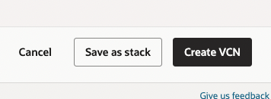
Figure 13 Create VCN button
  - Verify that the virtual network has been setup. You can compare with the following example.

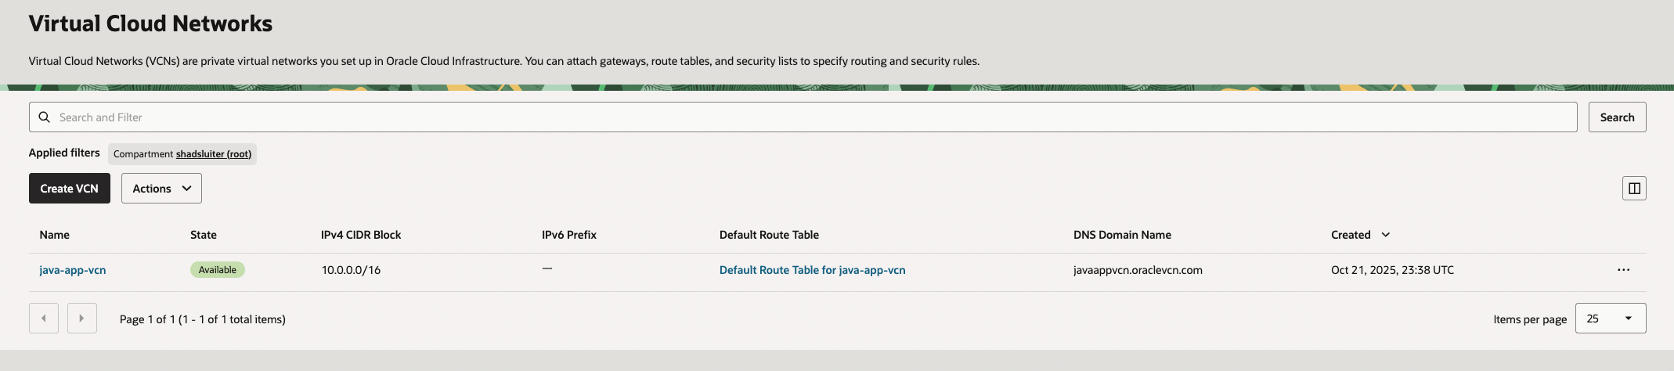
Figure 14 The virtual network, java-app-vcn has been created.

  - Click the java-app-vcn name to see the details about the network.
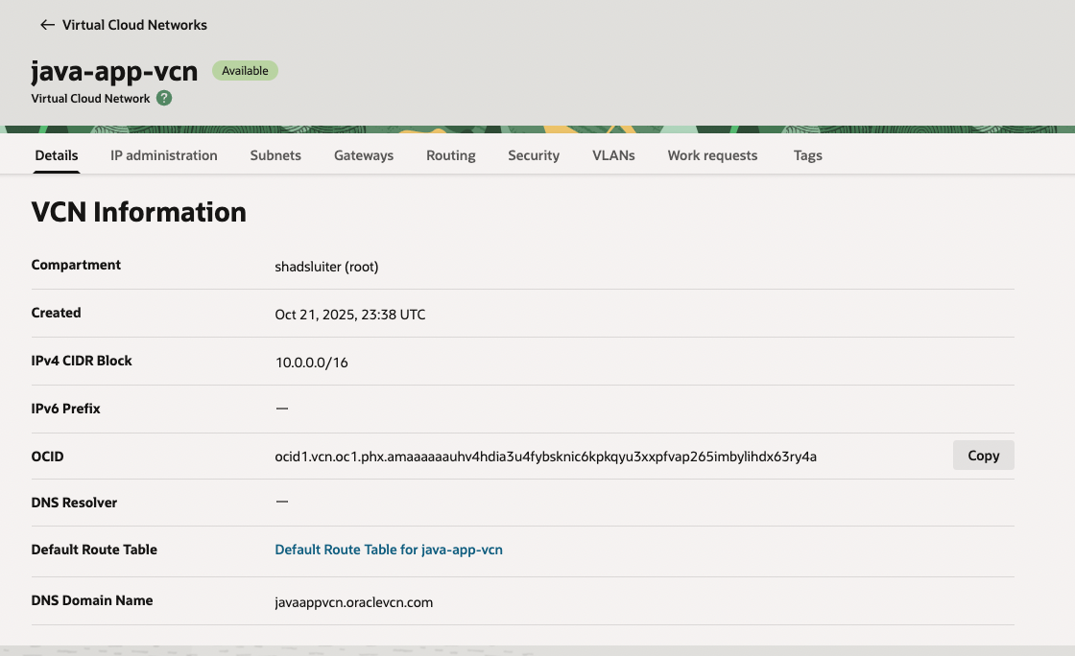
Figure 15 Example of a VCN details

Subnets
Next, we are going to divide the network space into a public and private zone.

- Select the Subnets tab under the java-app-vcn details page.
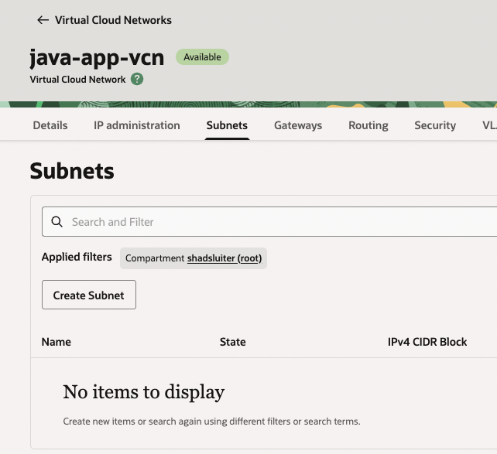
Figure 16 Subnets tab is shown

- Click the “Create Subnet” button.
- Fill Out the Subnet Form
- First, create the private subnet. Name it private-subnet.

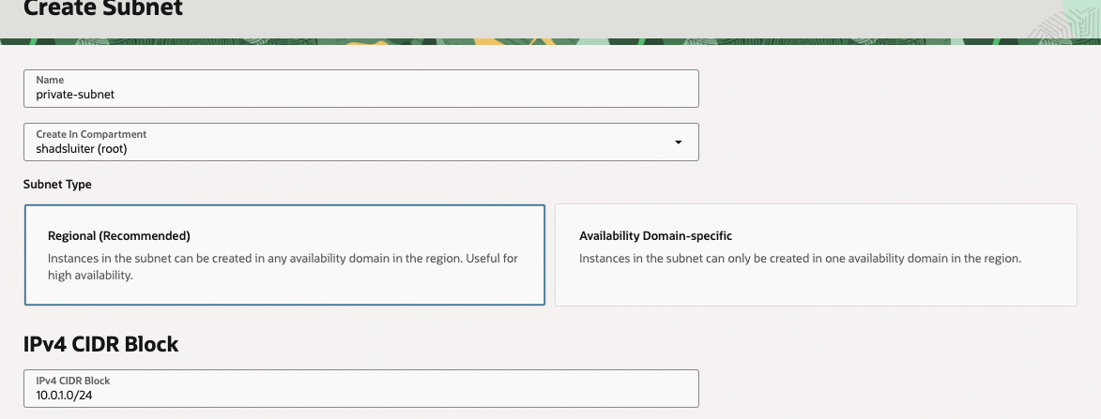
Figure 17 First step in creating the private subnet

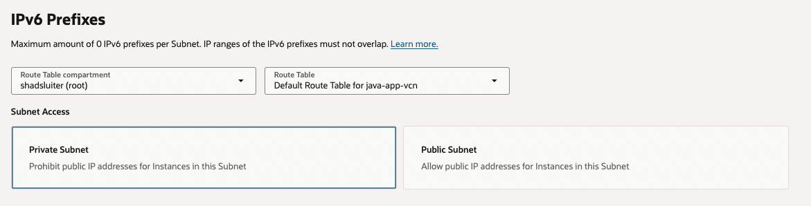
Figure 18 Additional properties for the private subnet

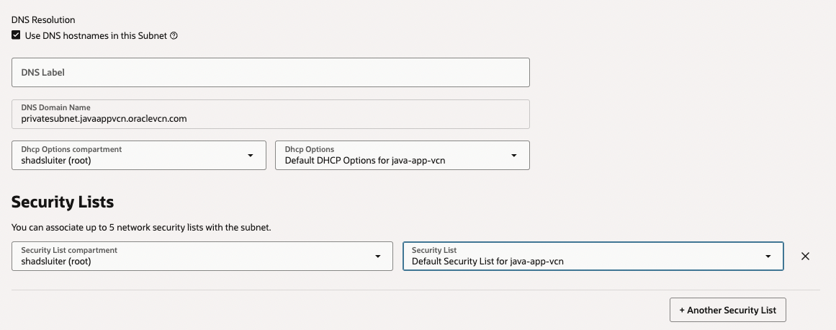
Figure 19 Screen shot of various subnet options.

Field | Example / What to Choose | Notes
Name | private-subnet | Use lowercase, descriptive name
Compartment | shadsluiter (root) | Keep the same as your VCN
Subnet Type | Choose Regional Subnet | Easier than AD-specific
IPv4 CIDR Block | 10.0.1.0/24 | A smaller slice of your VCN’s 10.0.0.0/16 network
Route Table | Use Default Route Table for java-app-vcn | Oracle created one automatically
Security List | Use Default Security List for java-app-vcn | You can adjust later
DHCP Options | Use the default | Normal behavior
Public Subnet | Check “Assign a public IPv4 address” (for now) | If you want to connect directly via SSH
Private Subnet | Leave unchecked (for your database) | Internal-only
- Click Create Subnet.
What does this mean 10.0.1.0/24?
Refer to this page to understand how a subnet is mathematically calculated.
https://www.digitalocean.com/community/tutorials/understanding-ip-addresses-subnets-and-cidr-notation-for-networking

Public Subnet
- Repeat the previous steps for a second subnet, naming the second subnet public-subnet.
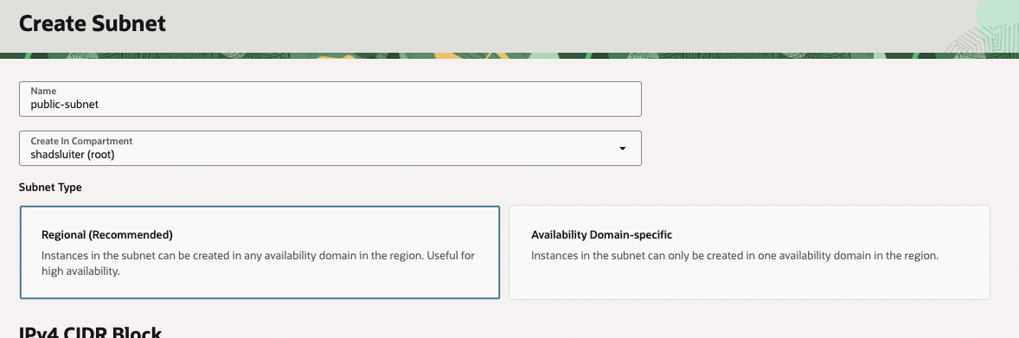
Figure 20 Initial options for the public subnet

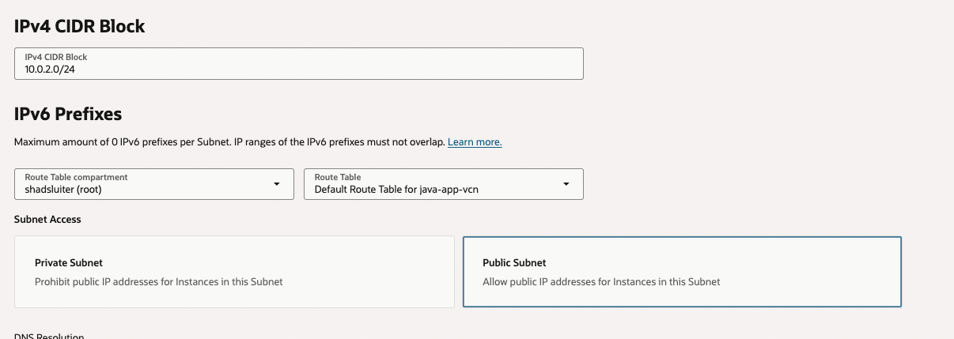
Figure 21 More choices for the subnet
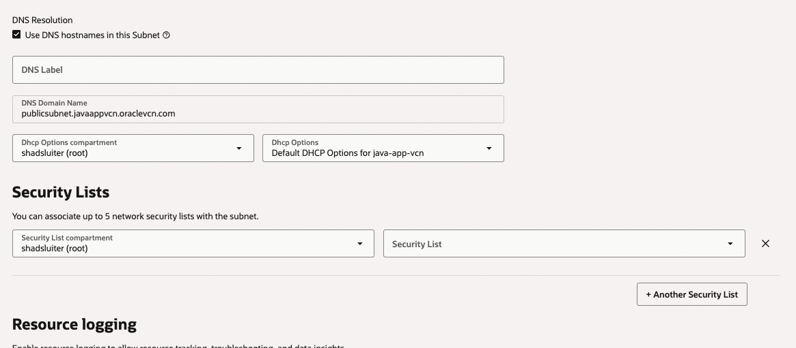
Figure 22 Additional options for the subnet

- Click Create and wait about 30 seconds.
- Refresh the page or switch to another tab and return.
- You should see a public and private subnet listed in the network.
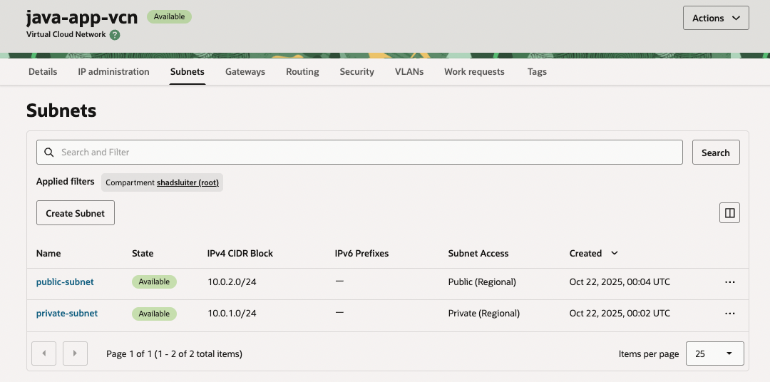
Figure 23 A public and private subnet have been created.

Why Two Subnets Were Created (Public + Private)
In a production-grade cloud architecture, it’s standard practice to divide your Virtual Cloud Network (VCN) into two subnets:
Subnet Type | Purpose | Example Resources | Visibility
Public Subnet | Accessible from the internet via public IP and internet gateway. Used for resources that need to communicate externally. | Load balancers, web servers, API gateways, bastion hosts | Externally reachable
Private Subnet | Isolated from direct internet access. Used for sensitive internal resources. | Databases, internal services, background jobs | Internal network only (no public IP)

Why We Created Both in the Tutorial

- The public subnet will host both the Spring Boot container and MySQL service. This allows easy access the app via a public IP without configuring complex routing or “jump hosts”.
- The private subnet is where secure, non-public components (like databases) reside .

Screenshot 2: “VCN and Subnets created.”
- Oracle Console → Networking → java-app-vcn.
- Include visible subnets: public-subnet and private-subnet.
- Caption: “VCN with both public and private subnets configured.”


- Take a screen shot of current status.
- Paste the image into a Word document.
- Put a caption below the image explaining what is being demonstrated.

Internet Gateway

The virtual network is currently isolated from the outside. The Gateway configuration allows virtual services access to the internet. If this is not set correctly, services will be unreachable.

- In Oracle configuration choices, open the Virtual Cloud Networks option.
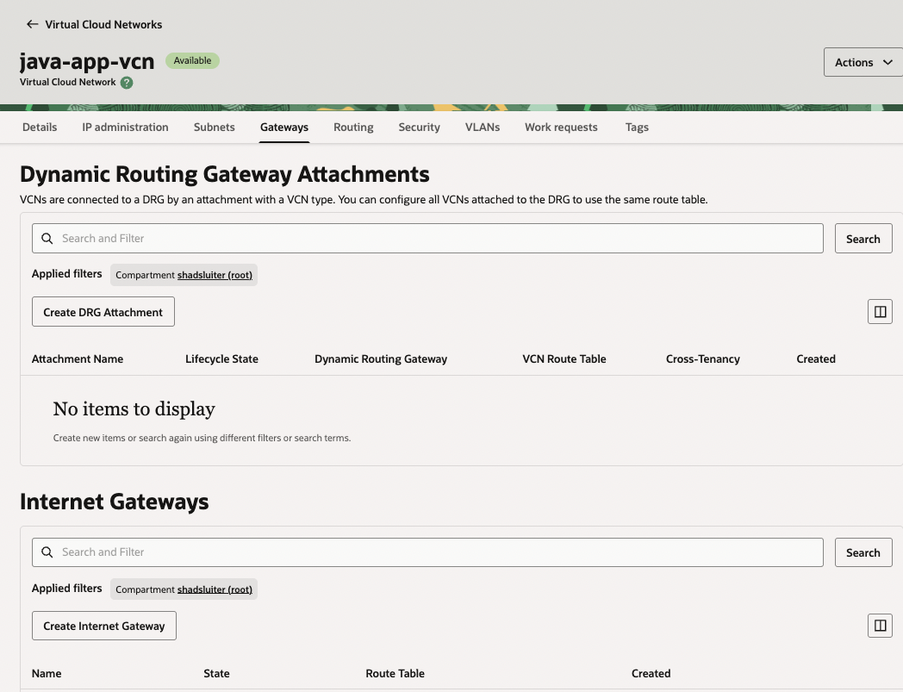
Figure 24 Settings for Gateways
  - Click Create Internet Gateway.
  - Name it java-app-igw or a similar name of your choice.

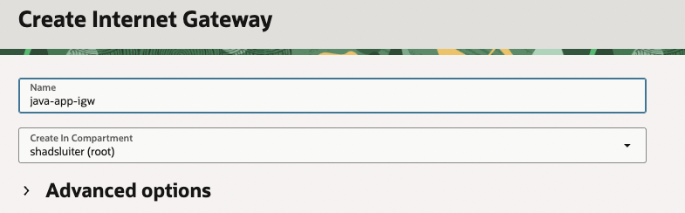
Figure 25 Creating a new gateway

Screenshot 3: “Internet Gateway and Route Table.”
- Show the IGW and route rule 0.0.0.0/0 → Internet Gateway.
- Caption: “Default route enables outbound traffic to the Internet.”

- Take a screen shot of current status.
- Paste the image into a Word document.
- Put a caption below the image explaining what is being demonstrated.

Route Rules & Network Filtering
Cloud networks use routing and filtering rules to control how traffic enters and leaves your Virtual Cloud Network (VCN). These steps determine what systems your app can reach (outbound) and who can reach your app (inbound).

Route Rules – Outbound Filter
Purpose:
Route rules act like traffic directions for data leaving your network. They define where packets go when an instance in your subnet tries to connect outside the VCN.
For example, without a route rule, your app could not reach the internet—even if it has a public IP.
- Select “Route Tables”
In your VCN dashboard, find the section labeled Route Tables.
  - Each subnet in your VCN uses one route table to determine how to send outbound traffic.
  - By default, a new VCN includes one route table named something like Default Route Table for java-app-vcn.
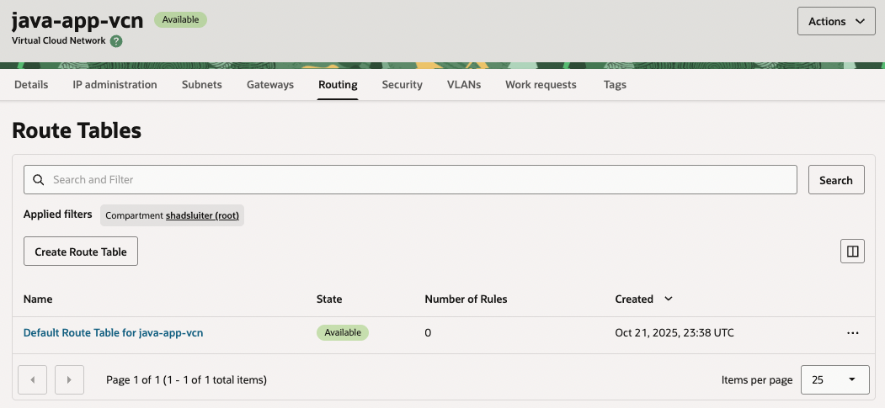

Figure 26 Routes options for the virtual network
- Click the Default Route Table Link
This opens the route table’s detailed configuration screen. Here you can see the existing routes (if any) and add new ones.

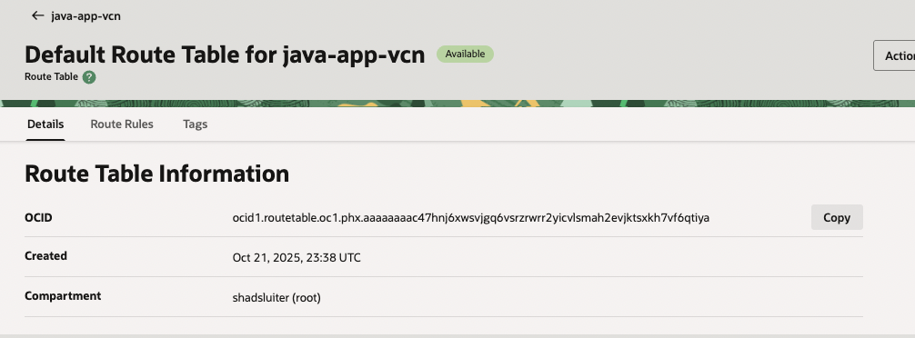
Figure 27 Details of the default route

- Click the Route Rules Tab
You’ll see that initially, there are no rules defined. This means outbound traffic currently has nowhere to go.

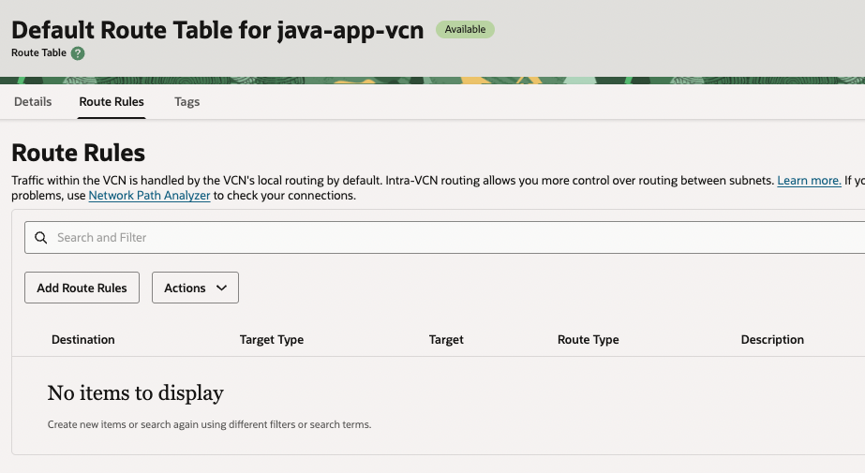
Figure 28 Initial, no route rules are defined

- Click “Add Route Rules”
This will allow you to define a new pathway for outbound traffic.

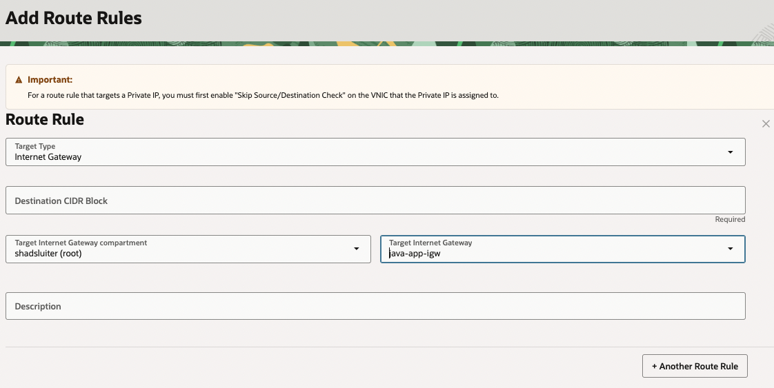

Set the CIDR Block and Target
- Destination CIDR Block: 0.0.0.0/0
This means “send all outbound traffic, regardless of destination, through this gateway.”
- Target Type: Internet Gateway
Select the Internet Gateway you created earlier for the VCN.
Result: All outbound traffic (e.g., app downloading dependencies, connecting to MySQL, etc.) can reach the internet.

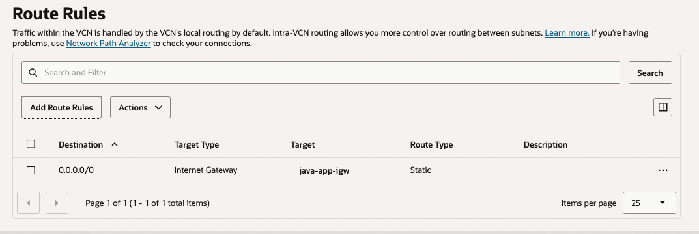
Figure 29 Route rules for default traffic. Only one rule is used.

Inbound Filtering – Security Lists (Ingress Rules)
Purpose:
Inbound filters, called Ingress Rules, control who can send requests into your network. This is how you securely open ports for specific services, like allowing MySQL Workbench on your local machine to connect to the MySQL database in your OCI network.
Without these rules, your database or app cannot be accessed even if it’s running.

Steps
- Open your subnet’s Security List (under the Security tab).
This list defines both inbound and outbound rules for that subnet.

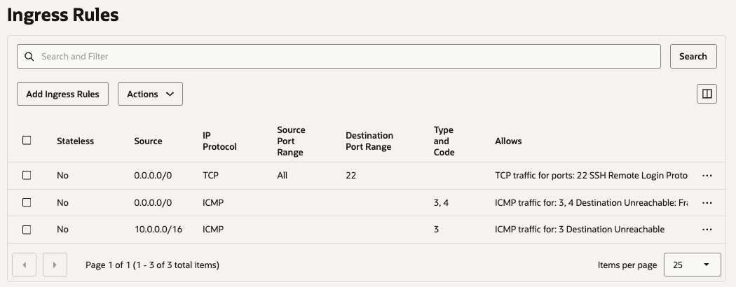
Figure 30 List of ingress rules configured on the network.

- Click “Add Ingress Rules.”
You’ll add a new entry that explicitly allows external systems to connect on the MySQL port.

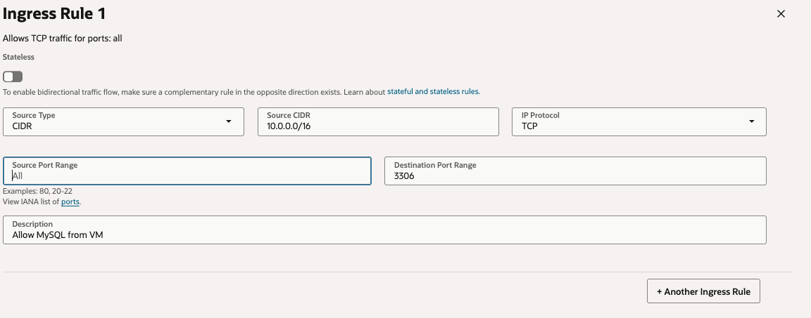
Figure 31 Adding a new ingress rule

Configure the Rule
- Source CIDR: 0.0.0.0/0
(For tutorial purposes, we allow all IPs; in production, you’d restrict this to known IPs.)
- Destination Port Range: 3306
(The default MySQL port.)
- Protocol: TCP
Result: The MySQL service in your subnet can now accept inbound connections from tools like MySQL Workbench or from your Spring Boot app running in another environment.

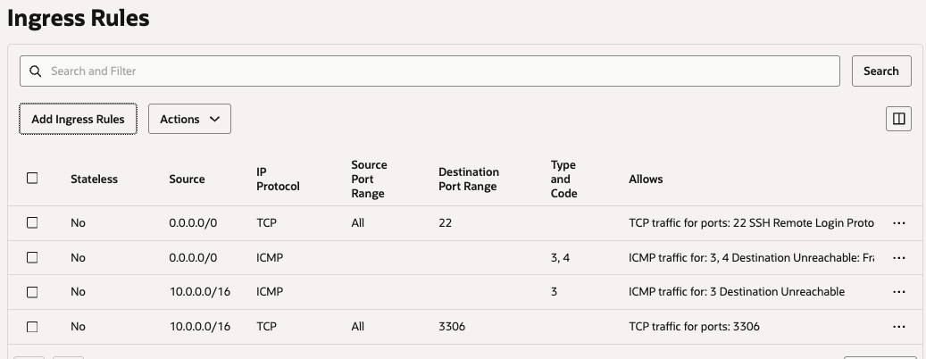
Figure 32 The newest ingress rule allows incoming traffic from all sources to connect using port 3306, the default mySQL port number.

Later in the tutorial, you will setup a web server running on port 8080. We need to open port 8080 for inbound traffic.
- click Add Ingress Rule:
  - Source CIDR: 0.0.0.0/0
  - IP Protocol: TCP
  - Destination Port Range: 8080
  - Description: Allow HTTP to Orders App
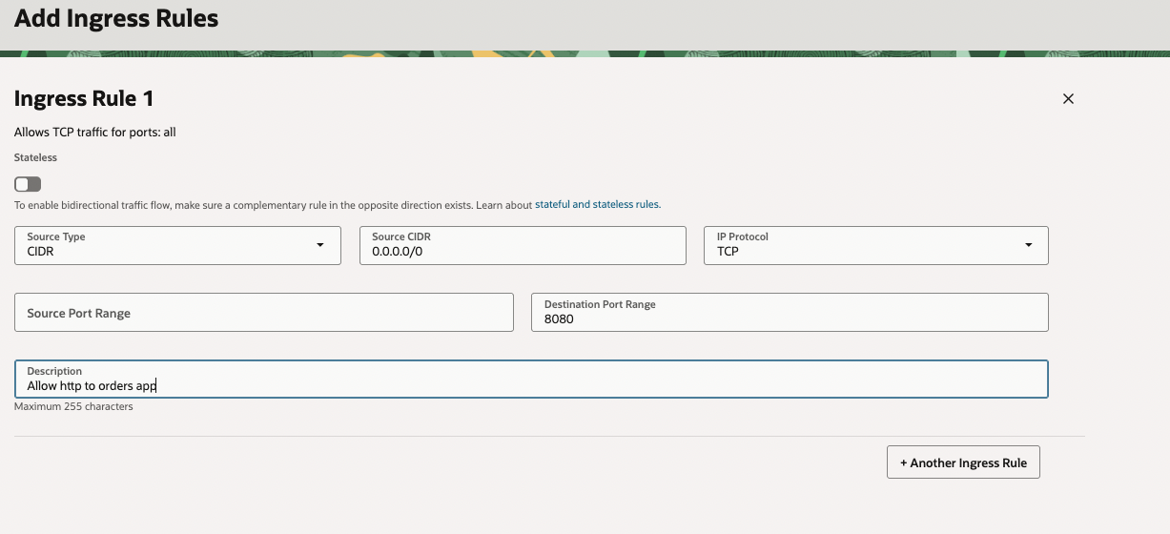
Figure 33 Ingress rule for allowing access to a web server

Summary of what we just setup

Concept | Purpose | Example in Tutorial
Route Rule (Outbound) | Defines how instances send traffic out of the VCN | 0.0.0.0/0 → Internet Gateway
Ingress Rule (Inbound) | Defines which external IPs and ports can connect in | Allow port 3306 for MySQL access
Simplification | We keep all resources in the public subnet to make testing easier | In production, MySQL would move to a private subnet

Screenshot 4: “Security List for public subnet.”
- Show ingress rule for TCP port 8080 (source 0.0.0.0/0).
- Show ingress rule for TCP port 3306 (source 10.0.2.0/24).

- Take a screen shot of current status.
- Paste the image into a Word document.
- Put a caption below the image explaining what is being demonstrated.

MySQL Database (OCI MySQL HeatWave)
Once you’ve chosen your Virtual Cloud Network (VCN) and subnet, the next step is configuring how your MySQL instance will run. We will determine where it’s hosted, how much compute power it gets, and how much storage to allocate.
- In the Oracle console page, navigate to Databases
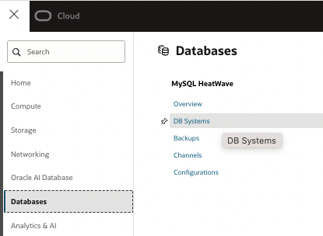
Figure 34 Location of databases in Oracle cloud setup
- Choose DB Sytems.
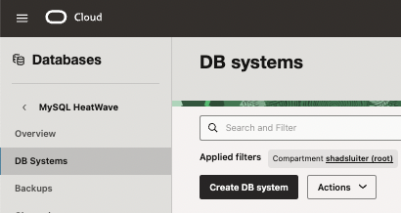
Figure 35 DB Systems option in Databases
- Choose Create DB system.
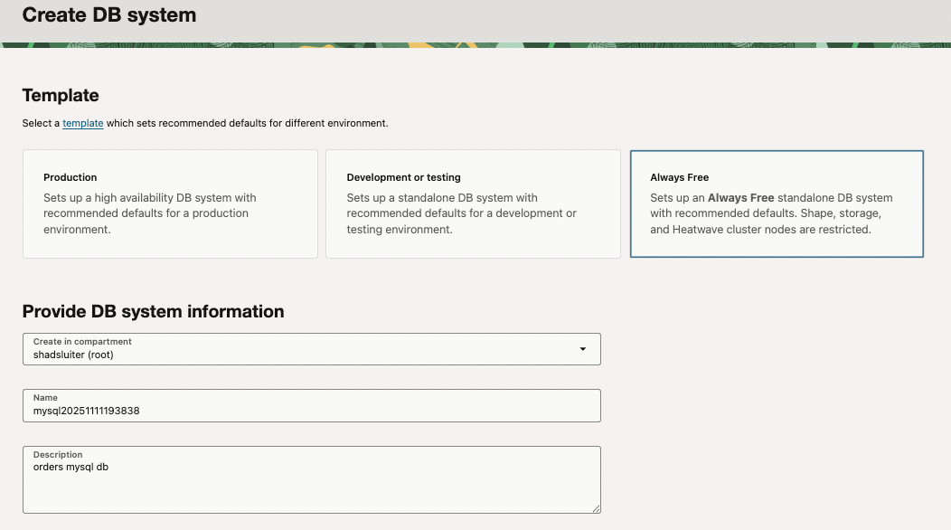
Figure 36 Creating a new database, using the default name provided

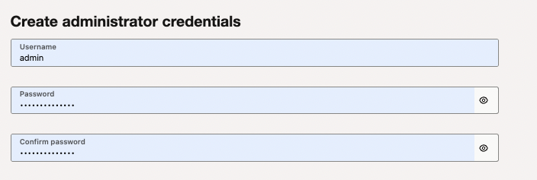
Figure 37 Add a username and password. Be sure to copy the password for later use.

- Choose the minimal standalone version of the server.
- Choose the java-app-vcn network.
- Choose the private subnet.
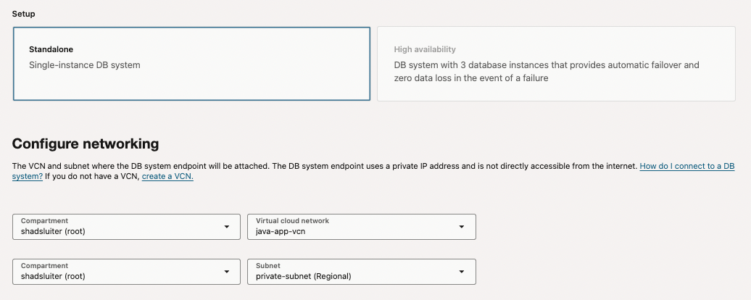
Figure 38 Choosing the minimal size and vcn location.

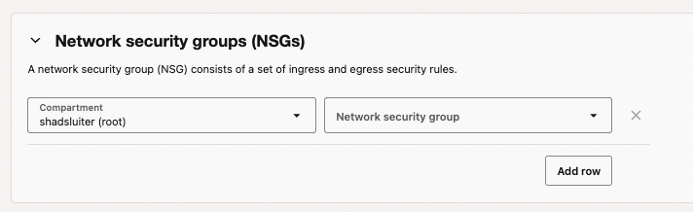
Figure 39 No changes are made to the nsg
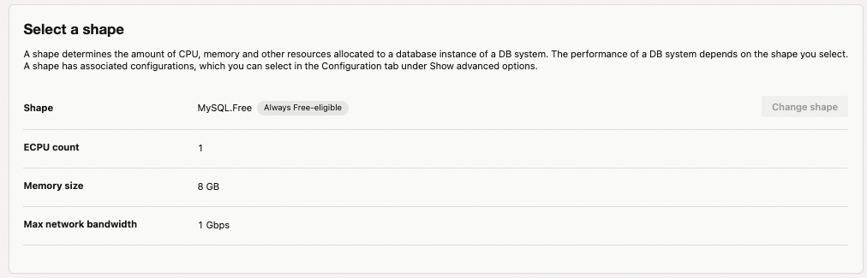
Figure 40 The "shape" of the server is minimal to save money.
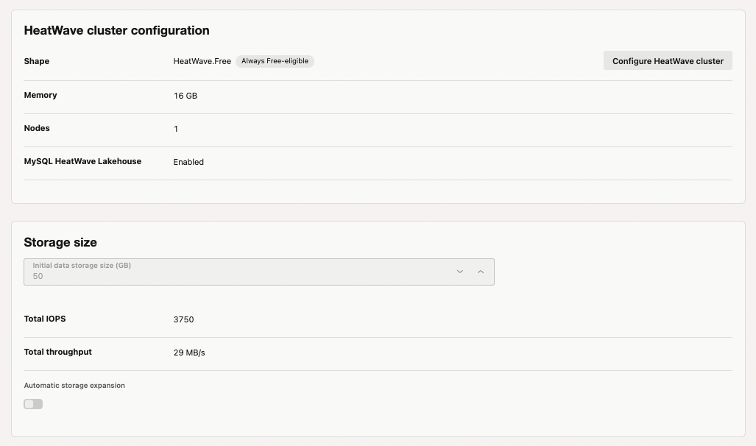
Figure 41 Storage is minimal to save money.
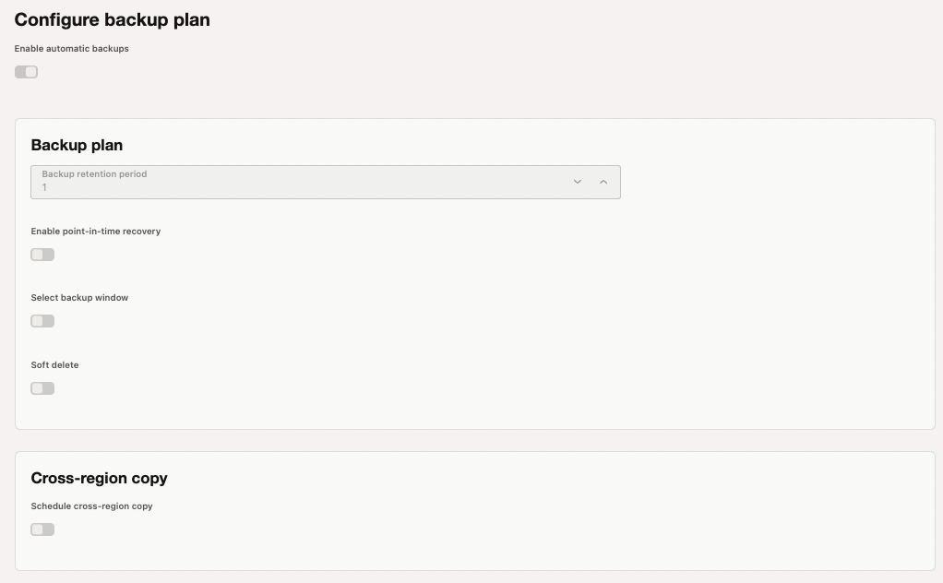
Figure 42 No backup settings have been chosen.
- Click Create when all options have been selected.

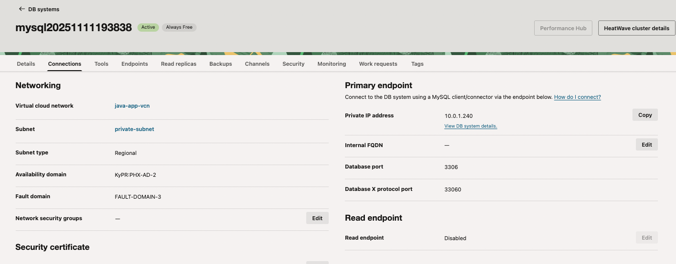
Figure 43 Summary of new database service.
- Verify what Availability Domain the MySQL service is located. We will need this in the next step.

Screenshot 5: “MySQL DB created in private subnet.”
- Show the DB instance page with Private IP (10.0.1.x).
- Caption: “MySQL Database Service deployed in private subnet.”

- Take a screen shot of current status.
- Paste the image into a Word document.
- Put a caption below the image explaining what is being demonstrated.

Connect with MySQL Workbench
Since your MySQL Database is deployed in the private subnet of your VCN, a “jump host” Compute instance is required.

PART 1 — Create the Compute VM (Bridge or Bastion Host)

Navigate to Create Instance
In the OCI Console:
- Go to Compute → Instances → Create Instance
- Name it something like mysql-vm
- Choose the compartment cst329JavaApp

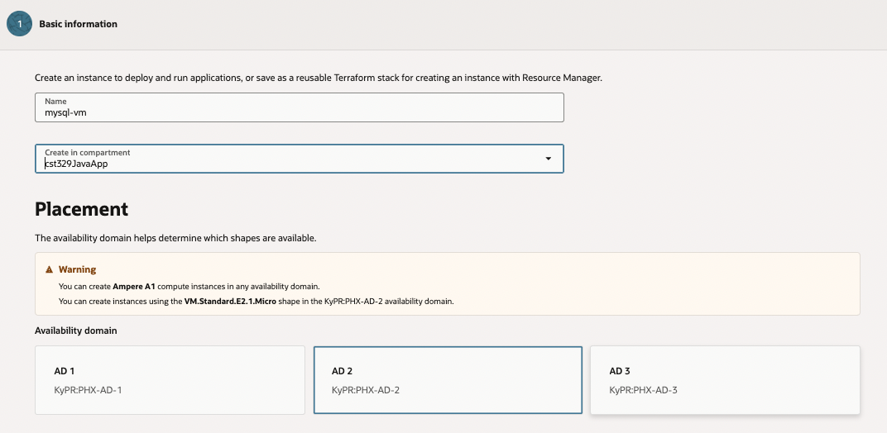

Choose Placement and Image
- Availability domain: same as your database (check the DB system page)
- Image: Oracle Linux 8
- Shape: VM.Standard.E2.1.Micro (Always Free)

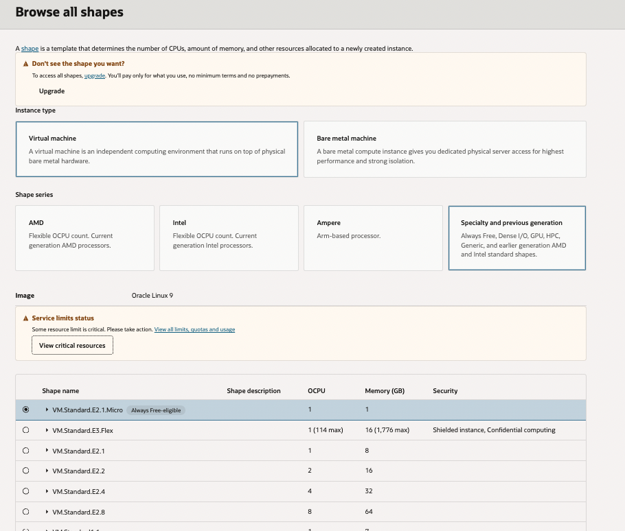
Figure 44 Choosing the hardware for the new compute instance
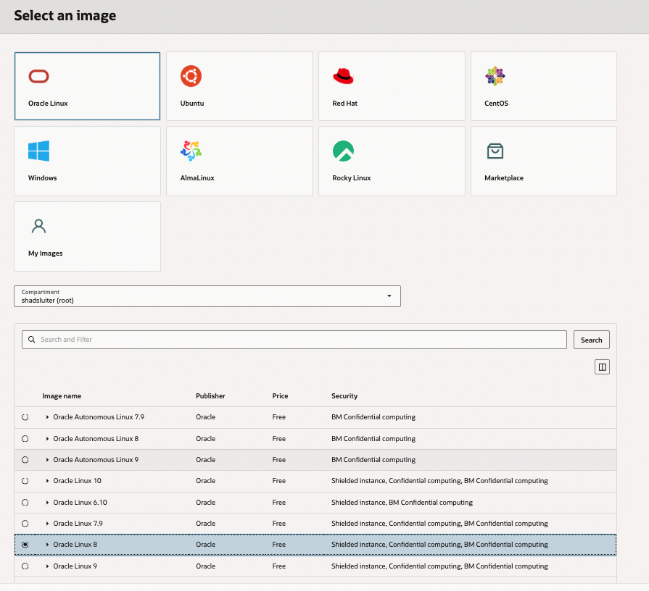
Figure 45 Selecting the operating system for the new vm

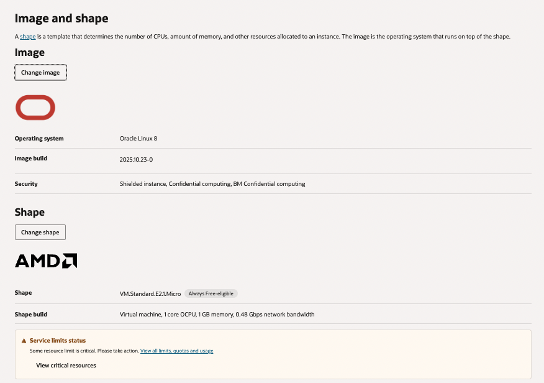
Figure 46 Summary of the hardware (shape) and the operating system (image)
- Continue with networking.

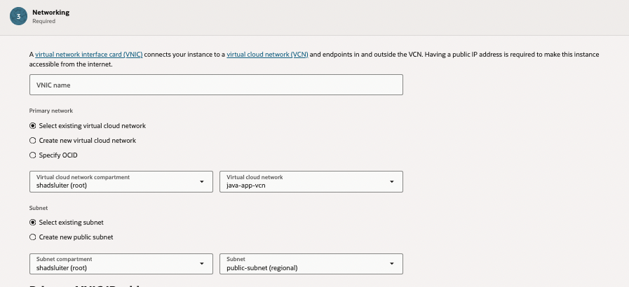
Figure 47 The new server is placed in the public subnet of the vcn
- Ensure that both an internal and external ip address are chosen.
- Download the provided private ssh key. You may store it in your cst323 documents or put it in the downloads folder (for temporary use).
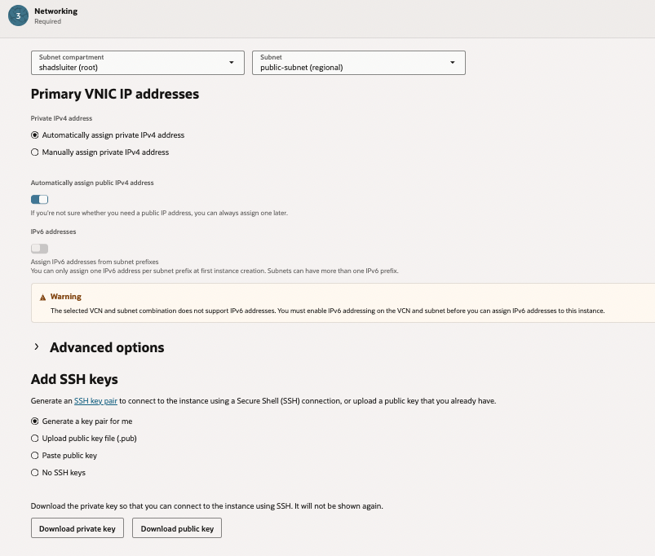
Figure 48 The new vm will be assigned an internal ip address as well as an external ip address
- Select storage requirements.

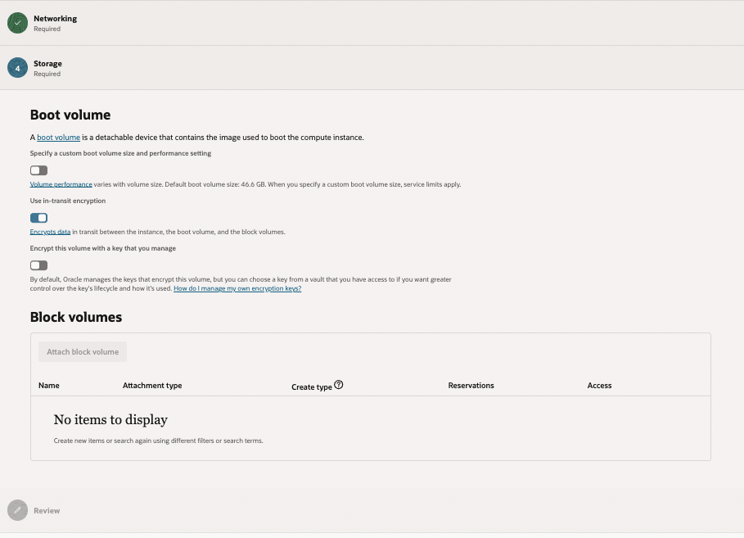
Figure 49 Default storage settings
- 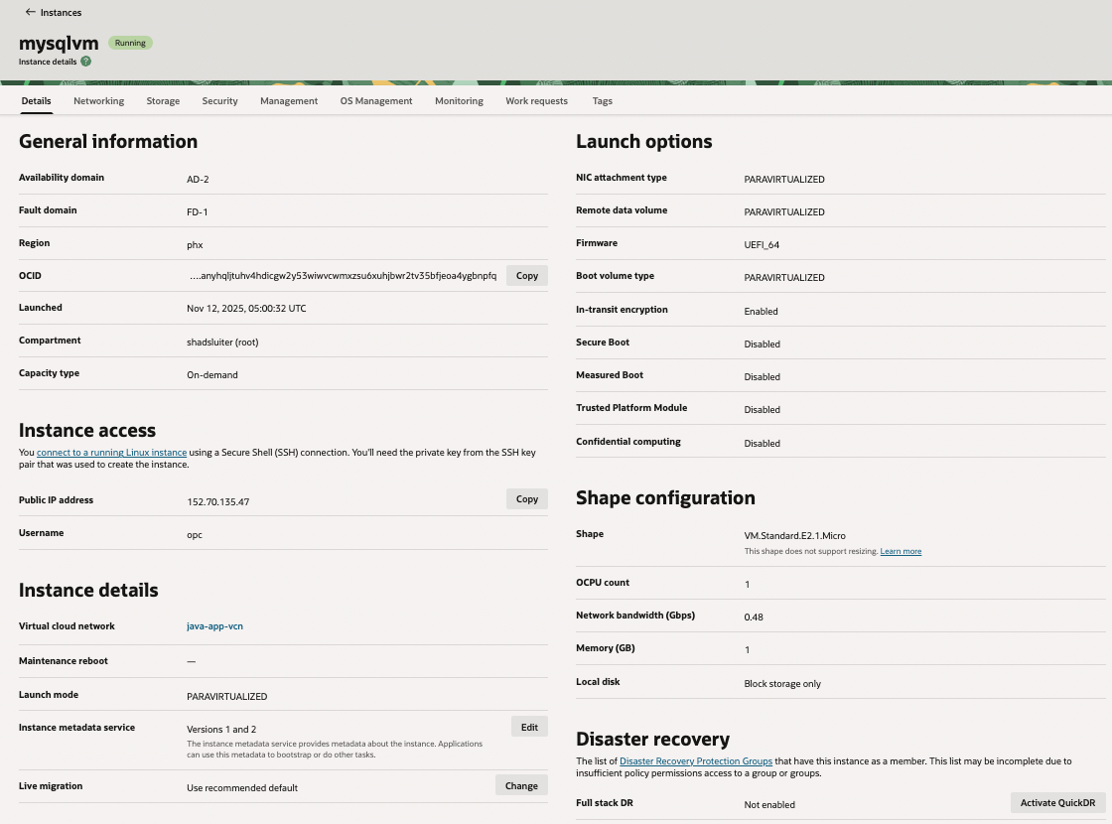Click the Create button to generate the new vm.
Figure 50 Summary of the new vm. The public IP address is important to note (and copy).

Screenshot 6: “Compute instance created.”
- Show instance summary: shape VM.Standard.E2.1.Micro, subnet public-subnet, public IP assigned.

- Take a screen shot of current status.
- Paste the image into a Word document.
- Put a caption below the image explaining what is being demonstrated.

The VM role

This new computer provides a bridge between your personal computer and the mysql database. We can manage the new machine using ssh.
- Open the terminal.
- Navigate to the location of the ssh certificate (Downloads folder).
- At terminal, type the following command, making adjustments for the ssh certificate as well as the public ip address of the vm.

shadsluiter@shads-MacBook-Pro Downloads % ssh -i ssh-key-2025-11-12.key opc@152.70.135.47
Activate the web console with: systemctl enable --now cockpit.socket

[opc@mysqlvm ~]$ whoami
opc

[opc@mysqlvm ~]$

Screenshot 7: “SSH session open to VM.”
- Terminal screenshot of successful SSH connection ([opc@mysqlvm ~]$).
- Caption: “Connected to OCI VM using private key.”

- Take a screen shot of current status.
- Paste the image into a Word document.
- Put a caption below the image explaining what is being demonstrated.

Optional Test

This installs the mysql client on the vm. In some cases, this may freeze up the virtual machine if not enough memory or storage was provisioned. If you freeze up the virtual machine, it can be rebooted from the servers list … menu (3 dots menu).
sudo dnf install mysql -y
This is for testing purposes. The vm can connect to the mysql now.

Connect from MySQL Workbench (Laptop)
Now you’ll connect through the VM using SSH tunneling.

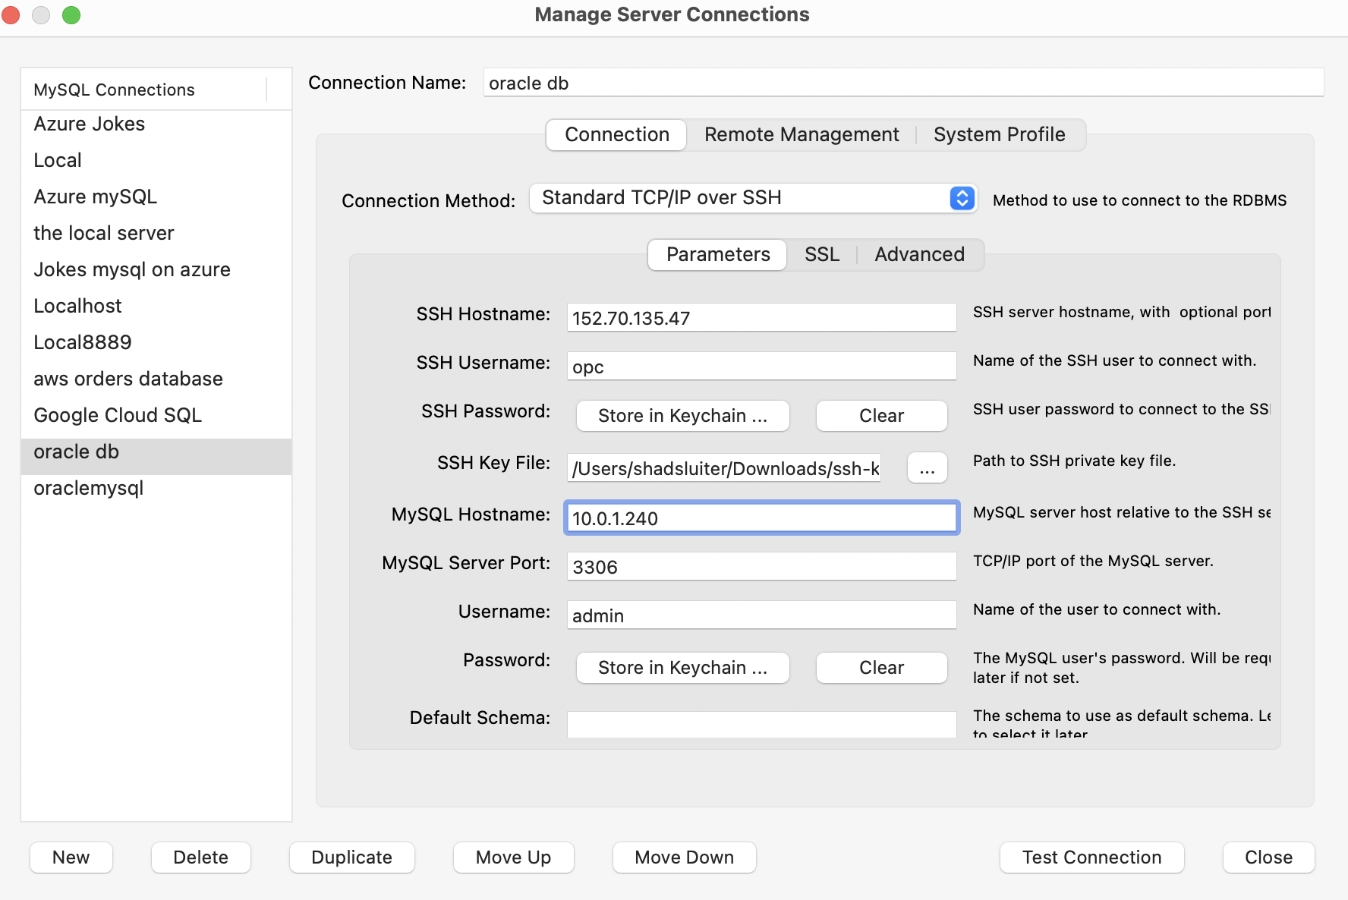
Figure 51 Settings for a new connection in mySQL workbench to the oracle mySQL server

Open MySQL Workbench

From the Home screen choose New Connection (+).
- In the Setup New Connection window, choose:

Connection Method:
Standard TCP/IP over SSH

SSH Section:
Field | Value
SSH Hostname | <VM_PUBLIC_IP> e.g. 152.70.135.47
SSH Username | opc
SSH Key File | Path to your private key that was downloaded in a previous step. (It is probably still in the Downloads folder)

MySQL Section:
Field | Value
MySQL Hostname | <DB_PRIVATE_IP> (e.g., 10.0.1.240)
MySQL Port | 3306
Username | admin
Password | your MySQL password
- Click Test Connection.
“Connection parameters are correct.”
- Click OK
- Double-click your new connection to open the SQL editor.

Screenshot 8: “Workbench connection settings.”
- Show dialog with:
  - Connection Method: “Standard TCP/IP over SSH”
  - SSH Hostname: <VM_PUBLIC_IP>
  - MySQL Hostname: <DB_PRIVATE_IP>
- Caption: “Workbench configured to tunnel through VM to private MySQL DB.”

- Take a screen shot of current status.
- Paste the image into a Word document.
- Put a caption below the image explaining what is being demonstrated.

Quick Troubleshooting
Issue | Fix
“Host unreachable” | Check that both subnets belong to same VCN and DB uses private subnet
“Access denied for user admin@host” | Confirm username is admin and correct password
“Timeout” | Ensure private subnet security list allows port 3306 from 10.0.2.0/24
“Could not resolve host” | Use the DB’s private IP

Final Summary
Resource | Subnet | Public IP | Purpose
MySQL DB | private-subnet (10.0.1.x) | ❌ | Database
Compute VM | public-subnet (10.0.2.x) | ✅ | SSH bridge
Laptop | internet | ✅ | MySQL Workbench access via SSH tunnel

Create Your Schema and Data
Once connected, create your database schema using the same commands from your AWS / GCP / Azure lessons.
Example to create a database.
CREATE DATABASE ordersdb;
USE ordersdb;
CREATE TABLE orders (
id INT AUTO_INCREMENT PRIMARY KEY,
customer_name VARCHAR(100),
product VARCHAR(100),
quantity INT,
price DECIMAL(10,2)
);
Import or insert sample data as needed.

Docker image → OCIR → Container Instance
Now it is time to configure the Java application. We will deploy a containerized version of the application to a server on Oracle cloud.

Information you’ll need handy
- Region (e.g., phx, iad, …)
- Compartment (where you create things)
- VCN + Subnet
  - Subnet that has 0.0.0.0/0 → Internet Gateway .
- MySQL details (private IP or hostname, DB name, username, password)
Vocabulary
- Compartment: a folder for resources (and permissions).
- VCN (Virtual Cloud Network): your private network.
- Subnet: a slice of your VCN (public can reach Internet; private cannot).
- OCIR: Oracle’s Docker registry—where you push/pull images.
- Container Instance: Oracle’s managed runtime for containers (no servers to patch).
Why use container? No OS package installs, no ssh/patching. It’s the lightest, least painful way to run one container.

Create Container for Orders App
  - Return to VS Code on your computer.
  - Ensure that Dockerfile is in the root of the project.
  - Complete the Dockerfile script. Use the following example.
# Lightweight Java runtime (use a version matching your build target)
FROM eclipse-temurin:21-jre

# Non-root runtime user (optional but good practice)
# RUN adduser --system --group appuser
# USER appuser

WORKDIR /app

# Copy the built JAR into the image
# (Adjust name or use a build ARG if your JAR name varies)
COPY target/orders-app-0.0.1-SNAPSHOT.jar app.jar

# Document the container’s listening port (informational)
EXPOSE 8080

# Start the Spring Boot app
ENTRYPOINT ["java","-Djava.security.egd=file:/dev/./urandom","-jar","/app/app.jar"]

- Run the Docker command at the terminal from the directory in the project. Be sure to include the period.
Docker build -t orders-app:latest .
You should see a success output…
[+] Building 27.6s (8/8) FINISHED docker:desktop-linux
=> [internal] load build definition from Dockerfile 0.0s
=> => transferring dockerfile: 591B 0.0s
=> [internal] load metadata for docker.io/library/eclipse-temurin:21-jre 0.2s
=> [internal] load .dockerignore 0.0s
=> => transferring context: 2B 0.0s
=> [1/3] FROM docker.io/library/eclipse-temurin:21-jre@sha256:66bb900643426ad01996d25bada7d56751913f9cec3b 27.1s
=> => resolve docker.io/library/eclipse-temurin:21-jre@sha256:66bb900643426ad01996d25bada7d56751913f9cec3b8 0.0s
=> => sha256:fd18b9ed8f5e6430b2e5b01ce34688a7c375b5a5ab76ed710e24a610e354cc1e 158B / 158B 1.1s
=> => sha256:66bb900643426ad01996d25bada7d56751913f9cec3b827fcb715d2ec9a0fbfc 7.18kB / 7.18kB 0.0s
=> => sha256:db0bfa45a41d289b64ed62c8f3a7f0071e3ed01677e3f6a38ab7a99c4b2a259c 1.94kB / 1.94kB 0.0s
=> => sha256:0000ad9844b7d825043e27aff02d64b0abd39810586e37eb34af1d6ed496c024 5.66kB / 5.66kB 0.0s
=> => sha256:adf670432170ff54aa7d7fec54b27ad51dc4b767bc00a3178b28176173ef130c 16.99MB / 16.99MB 25.9s
=> => sha256:d6d3072b7ee41b26a0c52ffc0714ce586e836d00c7f9936e7f5c4219d8993682 52.15MB / 52.15MB 23.0s
=> => sha256:a452d8b8a38c043118d3c800c54e6273302aa0642a20b0df0f628b8d0e8866ce 2.28kB / 2.28kB 1.3s
=> => extracting sha256:adf670432170ff54aa7d7fec54b27ad51dc4b767bc00a3178b28176173ef130c 0.5s
=> => extracting sha256:d6d3072b7ee41b26a0c52ffc0714ce586e836d00c7f9936e7f5c4219d8993682 0.6s
=> => extracting sha256:fd18b9ed8f5e6430b2e5b01ce34688a7c375b5a5ab76ed710e24a610e354cc1e 0.0s
=> => extracting sha256:a452d8b8a38c043118d3c800c54e6273302aa0642a20b0df0f628b8d0e8866ce 0.0s
=> [internal] load build context 0.5s
=> => transferring context: 60.54MB 0.5s
=> [2/3] WORKDIR /app 0.2s
=> [3/3] COPY target/orders-app-0.0.1-SNAPSHOT.jar app.jar 0.1s
=> exporting to image 0.1s
=> => exporting layers 0.1s
=> => writing image sha256:1919d6d06c66c1f3963e59329686daee719f146cdbfbcd1a3049bca2e98de070 0.0s
=> => naming to docker.io/library/orders-app:latest 0.0s

- Verify the new image exists. Type this at the terminal on your computer.
Docker images
You should see the newest container image in the list. This example shows a new image created 2 minutes ago.

shadsluiter@shads-MacBook-Pro products % docker images
REPOSITORY TAG IMAGE ID CREATED SIZE
orders-app latest 1919d6d06c66 2 minutes ago 372MB
helloworld latest 08d3df52cd5d 10 days ago 478MB
welcome-to-docker latest 66477e9efed8 12 days ago 273MB
docker/welcome-to-docker latest 05028304d2c2 3 months ago 14.4MB

Push your image to OCIR

Create an Auth Token (one-time)

- Return to Oracle cloud portal.
- Open the “Auth Tokens” section
- Open the User Details page.
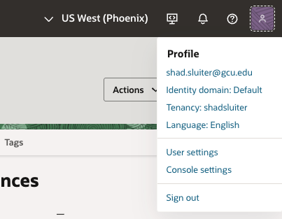
- Choose Auth Tokens.
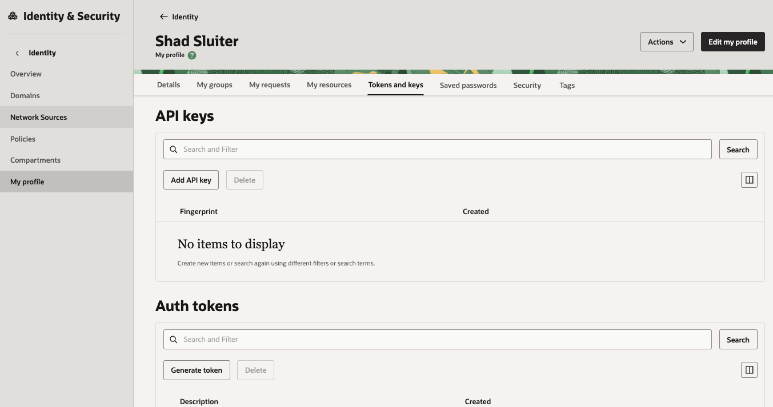
Figure 52 Auth tokens section of Identity

- Click Generate token.
- In the popup:
  - Enter a description like docker-login .
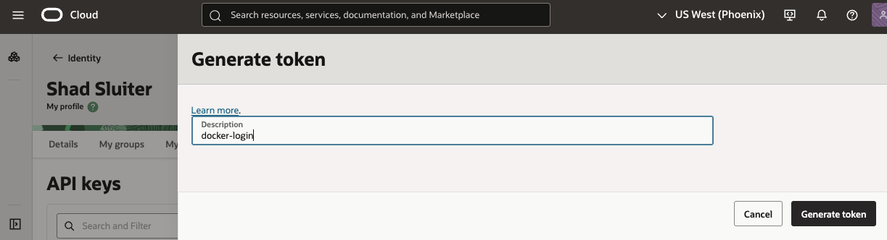
Figure 53 New login token is named
  - Click Generate token.
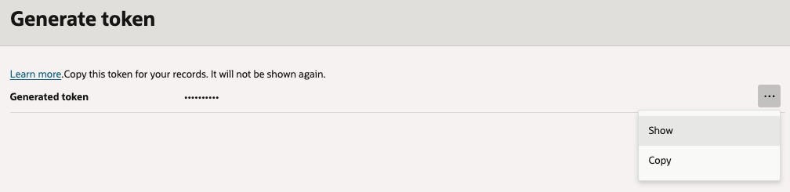
Figure 54 Token is displayed as hidden dots, but can be displayed in clear text.

- Choose the … button (3 dots) and choose Show

- Copy the long token that appears (looks like ocid1.authtoken.oc1..aaaaaaaa...).
You’ll only see it once — save it somewhere secure (password manager or text file).
Your token should look something like this.
[#Layfpwk9;W]81l}>ge
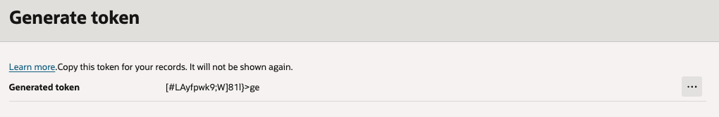
Figure 55 Token is displayed as clear text

Next Step – Use the token for Docker Login
1. We need to first get the container namespace for the application.
There are two methods:
- In Oracle console page.
Console → Developer Services → Container Registry (OCIR) → your Namespace appears at the top (short string like acme12345).
- Using the command line.
Open Oci cloud shell.
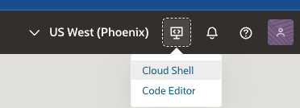
oci os ns get

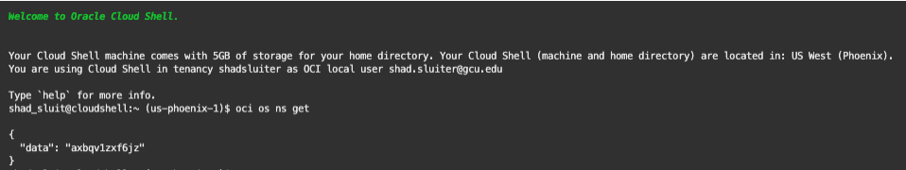
- Now use that token from your terminal to log in to Oracle Container Registry (OCIR).
docker login phx.ocir.io -u "axbqv1zxf6jz/shad.sluiter@gcu.edu" -p "[#LAyfdwk9;W]81l}>ge"
Replace:
- phx with your OCI region code if different (Phoenix = phx)
- The username format is:
<tenancy-namespace>/<user-email>
You’ll see:
Login Succeeded

Push Your Docker Image
- Tag the local docker image.

docker tag orders-app:latest phx.ocir.io/axbqv1zxf6jz/orders-app:v1

Tag does not produce any terminal output when it succeeds. It’s a “silent success” command — Docker just creates a second reference (a new name/tag) to the same local image.
The tag, v1 lets you specify, “Deploy exactly the image that was tested and approved.”
If you later make code changes, rebuild the JAR, and push again, you can tag it as:
docker tag orders-app:latest phx.ocir.io/axbqv1zxf6jz/orders-app:v2
That way the old version (v1) still exists and can be rolled back and the new one (v2) runs in parallel or replaces it cleanly.
- Let’s verify that the tag worked. Type the following command line statement.
docker images
- You should see two entries pointing to the same image ID. The v1 tag is the new item.
docker images
REPOSITORY TAG IMAGE ID CREATED SIZE
phx.ocir.io/axbqv1zxf6jz/orders-app v1 1919d6d06c66 9 minutes ago 372MB
orders-app latest 1919d6d06c66 9 minutes ago 372MB
helloworld latest 08d3df52cd5d 10 days ago 478MB
welcome-to-docker latest 66477e9efed8 12 days ago 273MB
docker/welcome-to-docker latest 05028304d2c2 3 months ago 14.4MB
This list confirms the tag command succeeded.
- Push the container to Oracle using this docker command. Substitute the name of your container. Replace the token with your own.
docker push phx.ocir.io/axbqv1zxf6jz/orders-app:v1

The push refers to repository [phx.ocir.io/axbqv1zxf6jz/orders-app]
3b2e2ff15d51: Pushing [============================> ] 35.06MB/60.52MB
28c146ece777: Pushed
7f5292a5a070: Pushed
9a4103b2f9ed: Pushed
0260ffda65a4: Pushing [================================> ] 108.3MB/164.9MB
c23219b40a25: Pushed
ab34259f9ca5: Pushing [==================================================>] 103.2MB
Screenshot 9: “Docker image pushed to OCIR.”
- Show terminal output of successful docker push.
- Caption: “Spring Boot image uploaded to Oracle Container Registry.”


- Take a screen shot of current status.
- Paste the image into a Word document.
- Put a caption below the image explaining what is being demonstrated.

Setup permission
- Return to Oracle console.
- Create new policy
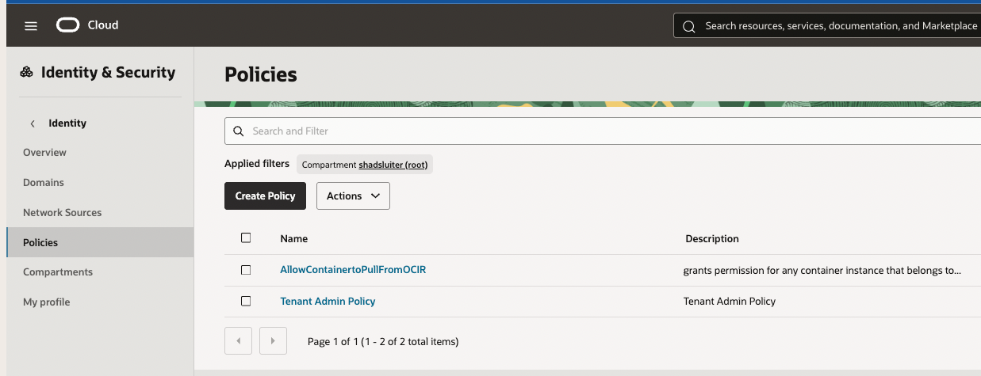
Figure 56 Policies for Identity and Security
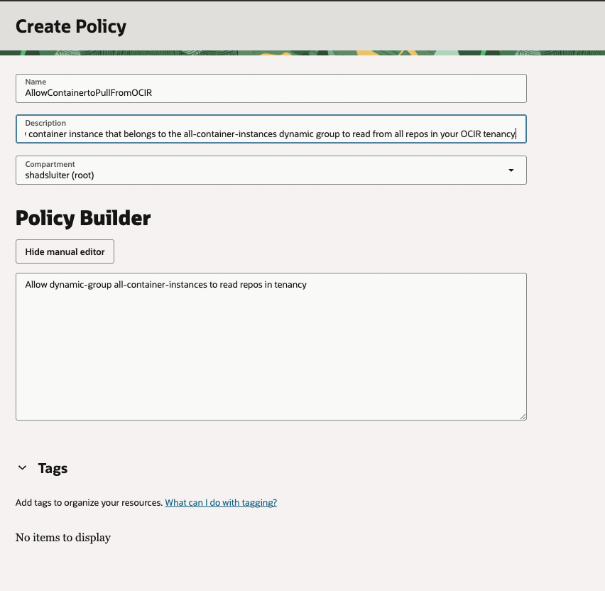
Figure 57 New policy name and settings for the container.
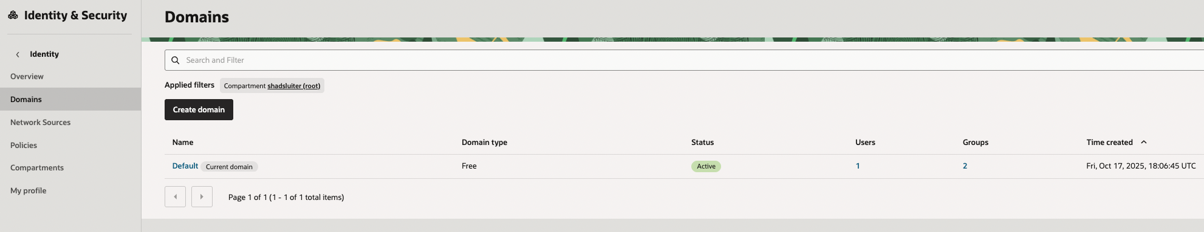

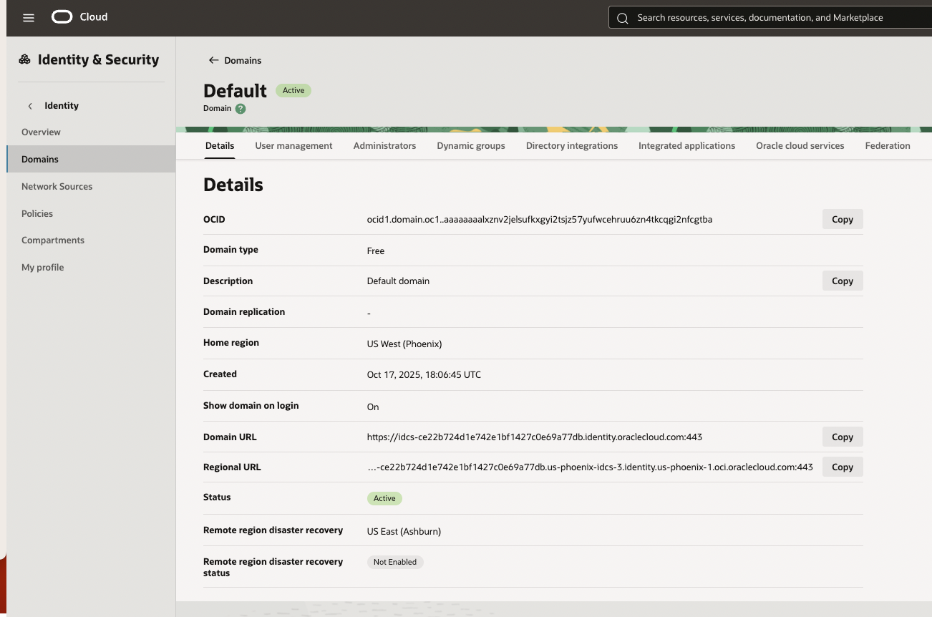
Figure 58 Details of the default domain
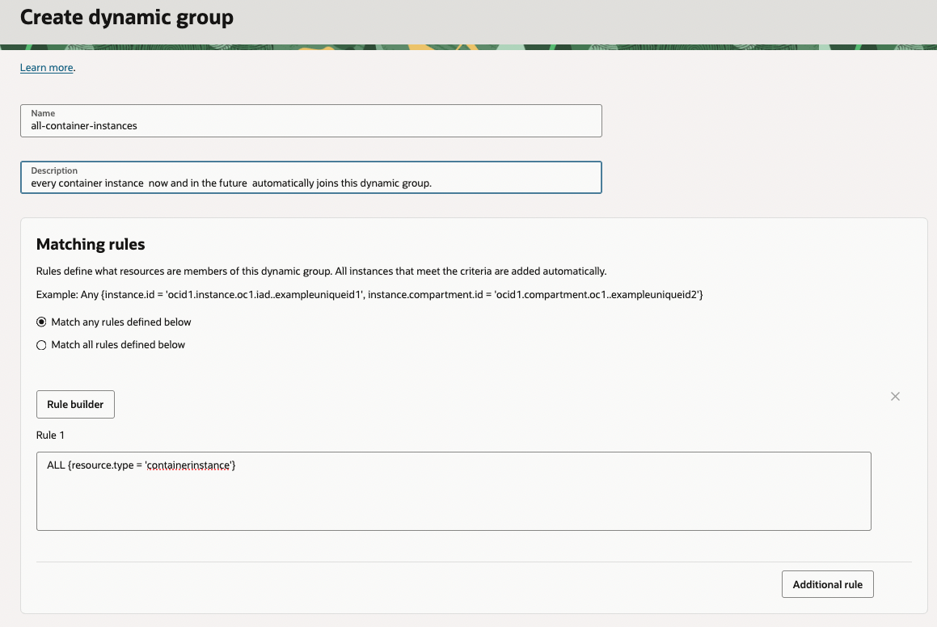
Figure 59 Dynamic group settings
Once this is in place, any new container instance can automatically pull from your private OCIR repo. No manual credentials needed.

Make Your OCIR Repository Public (Temporary Test)

1️ Go to your repo
In the OCI Console:
- Navigate to
☰ → Developer Services → Container Registry → Repositories
- You’ll see your repo — probably named orders-app.
- Click on the repo name.

2️ Open repository settings
On the repo details page:
- Look for the section titled Access or Visibility.
- It will say something like:
- Visibility: Private
Click the Edit button beside Visibility.

3️ Change to “Public”
Set:
Visibility → Public
This allows anyone (even without login) to pull the image using your repo URL:

Create the Container Instance (runs your container)
Console → Developer Services → Container Instances
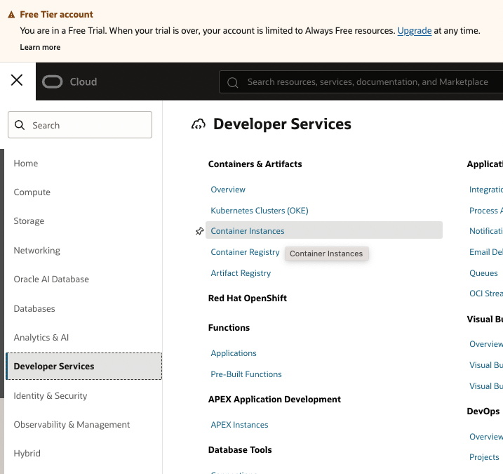
Figure 60 Viewing container instances
Create container instance

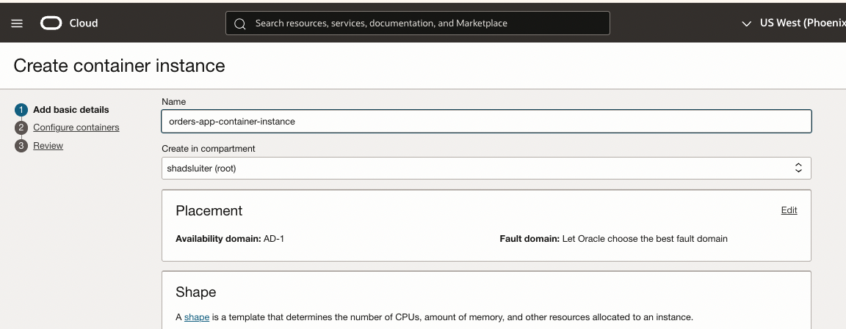
Figure 61 Setting up a container
- Compartment: pick your course/tenant compartment
- Name: orders-app-container-instance
- Shape: start small with Always Free choise.

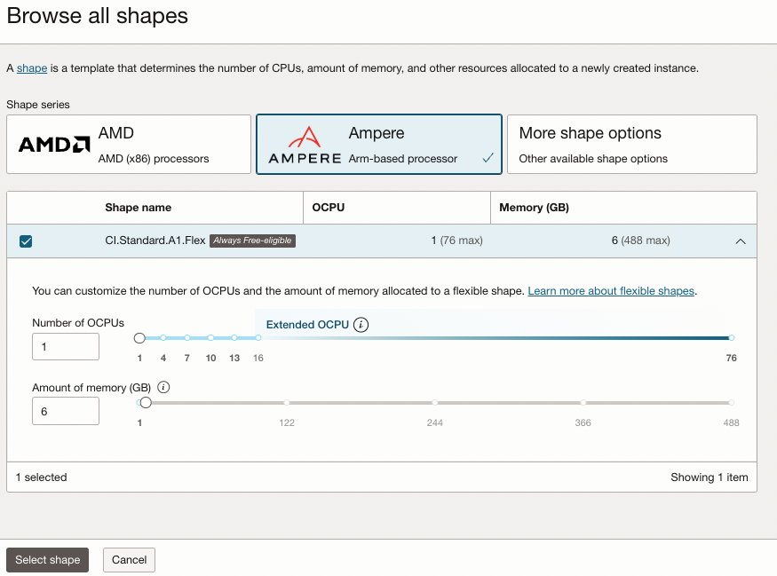
Figure 62 Selecting a minimal hardware option for the container

Networking
- VCN: your app VCN
- Subnet: choose a public subnet if you want to reach it from the Internet
- Assign public IPv4: Enable (so you can browse http://PUBLIC_IP:8080)

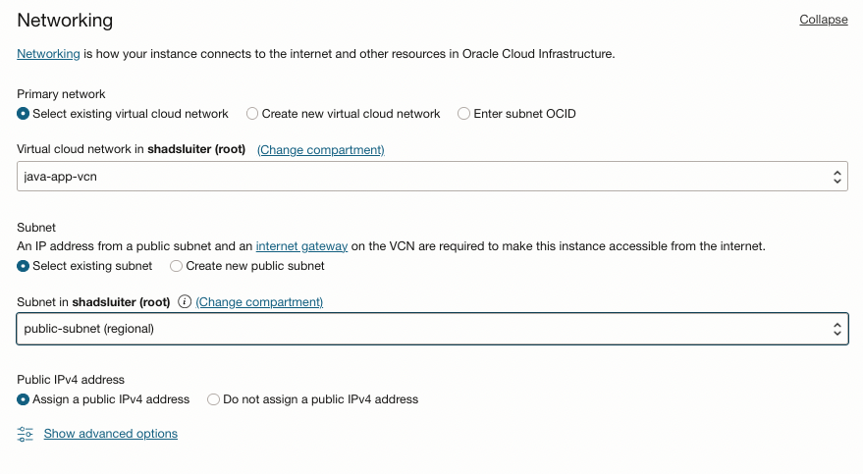
Figure 63 Networking options for the container

Add a container (the actual app)

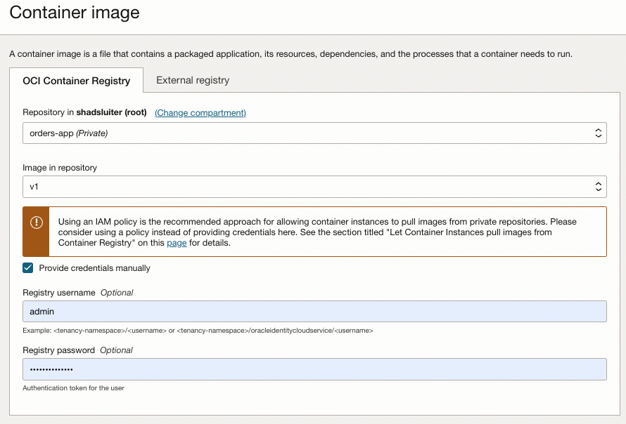
Figure 64 Setting the image

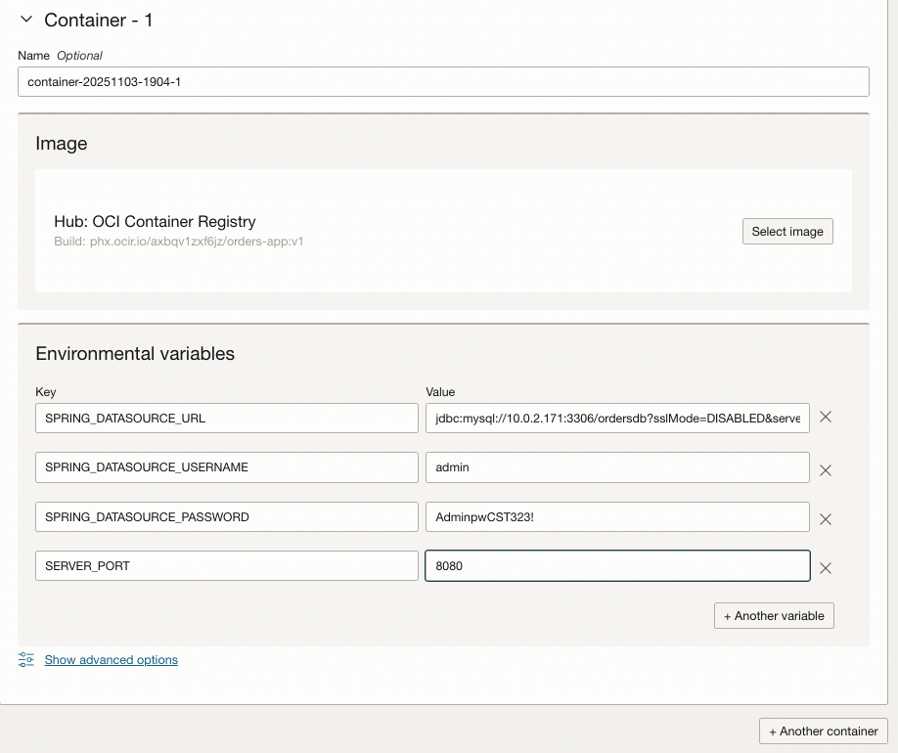
Figure 65 Adding environment variables for username, password etc. Use your actual ip addresses and password, not necessarily the ones pictured here.

Click Add container:
Variable | Value | Explanation
SPRING_DATASOURCE_URL | jdbc:mysql://10.0.1.171:3306/ordersdb?sslMode=DISABLED&serverTimezone=UTC | Uses your MySQL private IP (10.0.1.x) and database name ordersdb. The SSL mode is disabled for simplicity inside the same VCN.
SPRING_DATASOURCE_USERNAME | admin | Default admin user created by Oracle MySQL.
SPRING_DATASOURCE_PASSWORD | (your new password once reset) | You’ll set this to the password you assign using “Reset Admin Password.”
SERVER_PORT | 8080 | This is the port exposed by your Spring Boot app and the container (EXPOSE 8080 in your Dockerfile).

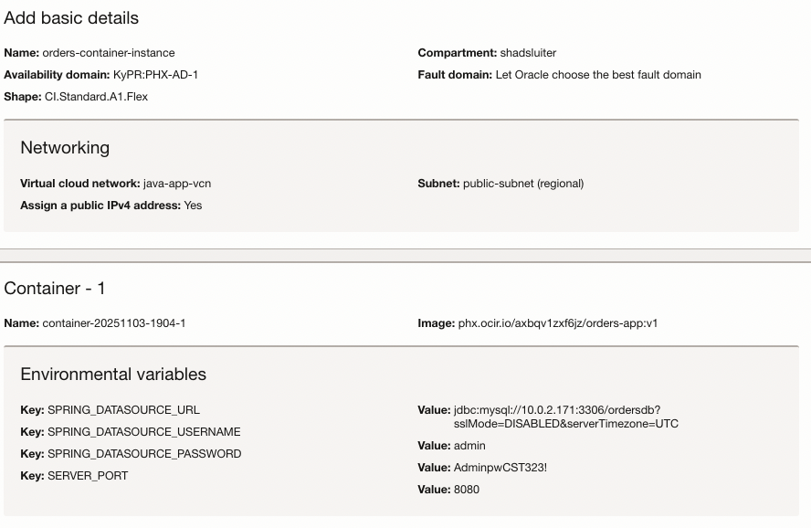
Figure 66 Summary of container details

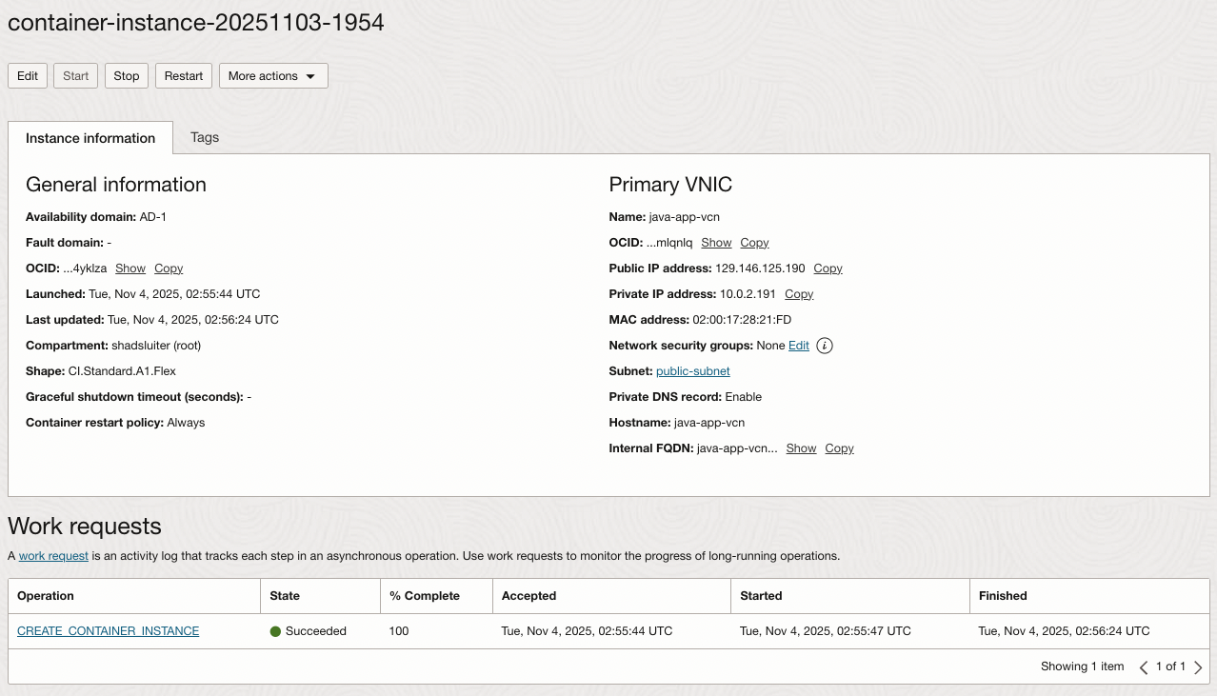
Figure 67 Success in deploying the container

Screenshot 10: “Container Instance running.”
- Show instance in Running state with public IP and port 8080.
- Caption: “Container instance successfully deployed and serving traffic.”

- Take a screen shot of current status.
- Paste the image into a Word document.
- Put a caption below the image explaining what is being demonstrated.
You’ve just run your Dockerized Spring Boot app on Oracle Cloud

Confirm and Run
Let’s confirm that the new application is actually serving traffic and connected to your database.

Step 1: Verify It’s Running
From the screenshot:
- Public IP: 129.146.125.190
- Port: 8080 (from your environment variable)
Try visiting this in your browser:
http://129.146.125.190:8080/orders
If your Spring Boot app exposes a root endpoint (like / or /api/orders), you should see:
- JSON output
- A “Whitelabel Error Page”
- or your custom homepage.

Screenshot 11: “Application in browser.”
- Browser showing http://<container_public_ip>:8080/orders with response.
- Caption: “Orders application accessible through OCI Container Instance.”

- Take a screen shot of current status.
- Paste the image into a Word document.
- Put a caption below the image explaining what is being demonstrated.

Debugging
Verify all steps - “One golden path”
- VCN: 10.0.0.0/16
- Subnets:
  - Private (DB): 10.0.1.0/24
  - Public (VM/container): 10.0.2.0/24
- IGW + Route: Default Route Table has 0.0.0.0/0 → IGW and is associated to the public subnet (and to the private subnet if needed for updates).
- Security Lists:
  - Public subnet: Ingress TCP 8080 from 0.0.0.0/0 (web)
  - Private subnet: Ingress TCP 3306 from 10.0.2.0/24 (VM/container only)
- DB: MDS in private subnet; note its private IP (10.0.1.x).
- VM: In public subnet; has public IP; SSH works with downloaded private key.
- Workbench: “Standard TCP/IP over SSH”; SSH host = VM public IP, MySQL host = DB private IP.
- Container: Env SPRING_DATASOURCE_URL points at 10.0.1.x; port 8080 exposed; public IP assigned to instance.
- OCIR: Logged in, image tagged phx.ocir.io/<namespace>/orders-app:v1, pushed, and container instance can pull.
Some fast fixes
- Image pull failed
Wrong image path/tag or missing image credentials. Re-enter NAMESPACE/USER and your token.
- App starts but “can’t connect to MySQL”
DB rule missing (3306 inbound from app subnet) or wrong IP/creds in SPRING_DATASOURCE_*.
- App not reachable from browser
8080 not opened in the container subnet Security List/NSG or the instance has no public IP.

Logs – Error messages are viewable from the Oracle console page.
  - Console → Container Instances → your instance → Logs. You should see Spring Boot start and Hikari connect.
  - Double-check Security List rules (8080 inbound to container subnet; 3306 inbound to DB subnet)
  - Verify the JDBC URL host/IP and credentials.

Open the Firewall (if needed)
Because you’re using the public-subnet, your container has a public IP — but you may still need to open port 8080 for inbound traffic.
- Go to
Networking → Virtual Cloud Networks → java-app-vcn → Security Lists
- Click the security list for your public-subnet.
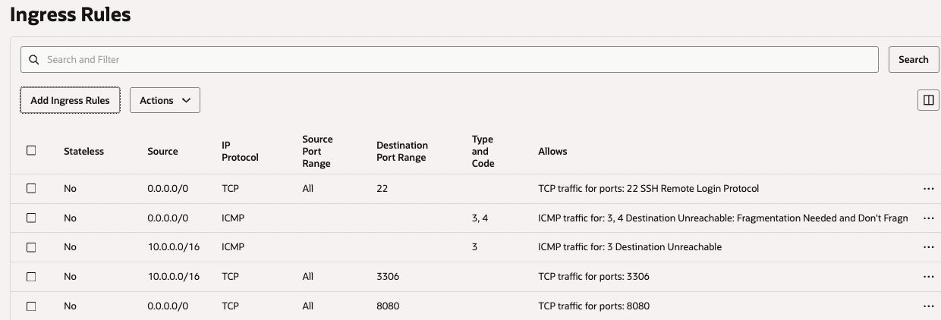
Figure 69 Ingress rule for 8080 allows external access to the web server.
- If port 8080 is not configured yet, click Add Ingress Rule:
  - Source CIDR: 0.0.0.0/0
  - IP Protocol: TCP
  - Destination Port Range: 8080
  - Description: Allow HTTP to Orders App

Figure 68 Setting up ingress rule for port 8080

Figure 69 Ingress rule for 8080 allows external access to the web server.
- Save and retry:
- http://129.146.125.190:8080

Database Connectivity Test
If the app starts but can’t connect to MySQL, check this in the logs:
Access denied for user 'admin'@...
If you see that, double-check:
- Your SPRING_DATASOURCE_URL uses the private IP (10.0.2.171).
- MySQL allows connections from your container subnet.
- Port 3306 is open for inbound access in the MySQL subnet security list.
Click Create and wait for Running.

Collaborating with AI
Exploring, questioning, and extending your Oracle Cloud deployment
The goal of this section is to help you think beyond the step-by-step guide.
Use an AI assistant (such as ChatGPT or Gemini) to analyze, challenge, or extend what you learned in this activity.
Document your responses and any generated examples in your Word submission beneath the “Collaborating with AI” heading.

AI Question 1 — Challenging Assumptions
Prompt:
“In this activity, we deployed the MySQL Database Service in a private subnet and accessed it through a public VM. Ask the AI: What are the security and cost trade-offs of this architecture compared to placing the database in a public subnet?”
Instructions:
- Follow-up the AI answer with further questions until your curiosity is satisfied.
- Summarize in your own words what you learned.
- Identify one architectural change you would make for a production system.
- Label this section 1A – Security and Cost Reflection.

AI Question 2 — Exploring Extensions
Prompt:
“Ask the AI: How could this same Spring Boot Orders application be deployed using a different Oracle service (for example, OKE – Oracle Kubernetes Engine, Functions, or OCI App Dev?”
Instructions:
- Request a side-by-side comparison (Oracle Container Instances vs OKE or Functions).
- Follow-up the AI answer with further questions until your curiosity is satisfied.
- Summarize in your own words what you learned.
- Label this section 2A – Platform Comparison and Extensions.

AI Question 3 — Cross-Cloud Perspective
Prompt:
“Ask the AI: How does deploying a Java application with MySQL on Oracle Cloud compare to similar workflows on AWS (Aurora + ECS), Azure (Database for MySQL + Container Instances), or Google Cloud (SQL + Cloud Run)? Which platform might best suit different project priorities such as cost, performance or ease of use?”
Instructions:
- Follow-up the AI answer with further questions until your curiosity is satisfied.
- Summarize in your own words what you learned.
- Conclude with a short paragraph: Which platform would you personally choose for a future project, and why?
- Label this section 3A – Cross-Cloud Reflection.

Submission Guidelines
- Choose one of the AI conversations and summarized result after your verification screenshots in the same Word document.
- Use clear subheadings (1A, 2A or 3A) and short reflections in your own words.
- Each response should be about 150 – 200 words

Review Questions
Although not graded, these questions will help you prepare for upcoming assessments.
1.
You deployed the Orders app to Oracle Container Instances, but it fails to connect to MySQL. Which configuration should you verify first?
A) Ensure the container image was built using Java 17.
B) Check that the database’s private IP and port 3306 are reachable from the container subnet.
C) Verify that the container’s storage mount points are correct.
D) Rebuild the container with an updated JAR file.
2.
Your database was accidentally created in the public subnet. What is the primary architectural risk of keeping it there?
A) Increased latency between subnets.
B) Unnecessary storage charges.
C) Direct Internet exposure of port 3306.
D) Limited access from Oracle Container Registry.
3.
When choosing between a Compute VM and a Container Instance for hosting the Spring Boot app, which statement best compares the two?
A) A VM requires less setup and is automatically scaled.
B) A Container Instance provides faster deployment with minimal OS management.
C) Both are identical in cost and configuration.
D) The VM is preferred because containers cannot access databases in private subnets.
4.
During configuration, you notice that the route table for the private subnet includes 0.0.0.0/0 → Internet Gateway. What does this indicate?
A) The subnet allows inbound SSH connections.
B) The private subnet was misconfigured as public.
C) The database can only be accessed internally.
D) The VCN uses peering to connect to another region.
5.
A student wants to skip creating the Compute VM and connect from MySQL Workbench directly to the database in a private subnet.
What would an AI assistant likely explain as the best alternative?
A) Use a Bastion host to tunnel connections securely.
B) Modify ingress rules to allow 0.0.0.0/0 on port 3306.
C) Switch to Oracle Autonomous Database.
D) Use the MySQL X protocol instead of TCP/IP.
6.
If the MySQL service becomes unreachable after changing VCN security rules, which diagnostic command on the VM would best confirm a networking issue?
A) ps -aux | grep mysql
B) nc -vz <db_private_ip> 3306
C) mysql -u admin -p
D) java -jar orders.jar
7.
What is the practical benefit of deploying the database in a different subnet than the web application?
A) Faster access due to reduced routing.
B) Logical isolation and targeted firewall control.
C) Lower CPU utilization.
D) Simpler DNS configuration.
8.
When building the Docker image for the Orders app, why must environment variables such as SPRING_DATASOURCE_URL be configured in the container service rather than inside the code?
A) It reduces build time for Maven.
B) It externalizes configuration for secure and flexible deployment.
C) It enables real-time debugging of environment variables.
D) It ensures MySQL creates the schema automatically.
9.
You plan to replicate this setup on AWS. Which AWS components most closely correspond to Oracle’s MDS, Container Instances, and VCN?
A) RDS for MySQL, ECS Fargate, and VPC.
B) Aurora Serverless, Lambda, and CloudFront.
C) EC2, Elastic Beanstalk, and Route 53.
D) S3, CloudFormation, and DynamoDB.
10.
After completing the tutorial, your team wants to automate the full deployment using infrastructure-as-code. Which Oracle tool or feature would best accomplish this?
A) Oracle Cloud Guard
B) Oracle Resource Manager (Terraform)
C) MySQL HeatWave Dashboard
D) OCI Vault

Answer Key with Explanations
1 – B
Check that the database’s private IP and port 3306 are reachable from the container subnet.
The most common cause of connection failure is a blocked or misrouted connection. Verifying network reachability ensures the container can actually see the database before debugging app code or rebuilding images.
2 – C
Direct Internet exposure of port 3306.
Placing MySQL in a public subnet assigns a public IP, exposing its port to the Internet. This violates best practices and creates a major security risk.
3 – B
A Container Instance provides faster deployment with minimal OS management.
Containers abstract away OS-level setup, making them lightweight and ideal for quick deployments. A VM gives more control but requires full OS maintenance.
4 – B
The private subnet was misconfigured as public.
A route table with 0.0.0.0/0 → Internet Gateway means the subnet can reach the Internet directly. A true private subnet should route through a NAT Gateway or have no Internet route at all.
5 – A
Use a Bastion host to tunnel connections securely.
When direct access to private subnets is needed, a Bastion host (or Oracle Bastion service) provides a secure bridge for SSH or database tunneling without exposing the database publicly.
6 – B
nc -vz <db_private_ip> 3306
The nc (netcat) command tests TCP connectivity to a host and port. It confirms whether the MySQL port is open and reachable at the network level which is ideal for diagnosing firewall or route issues.
7 – B
Logical isolation and targeted firewall control.
Separating the app and database into distinct subnets enables tighter control over which traffic is allowed between them which is a standard networking practice.
8 – B
It externalizes configuration for secure and flexible deployment.
Environment variables keep credentials and connection strings outside the source code. This makes deployments portable and reduces the risk of exposing secrets in git repositories.
9 – A
RDS for MySQL, ECS Fargate, and VPC.
These AWS services parallel Oracle’s MDS, Container Instances, and VCN: managed MySQL, serverless container hosting, and isolated networking.
10 – B
Oracle Resource Manager (Terraform).
Resource Manager automates OCI deployments using Terraform scripts. This enables repeatable, version-controlled infrastructure setup.

Tip for Study

- Reread questions 1–4 for networking logic and subnet design.
- Review 5–8 for architecture and DevOps reasoning.
- Focus on 9–10 for cross-platform and automation insights which are often assessed in higher-level exams.

Deliverables and Rubric
Submit one Word document that includes:
- Verification Screenshots —
Key images captured throughout the activity showing progress (VCN setup, route tables, MySQL creation, VM configuration, successful MySQL Workbench connection, container deployment).
Each screenshot should include a brief caption describing what it demonstrates.
- Collaborating with AI Section —
Choose one subsection (1A, 2A, 3A) containing your AI-assisted responses:
  - 1A: Security and Cost Reflection
  - 2A: Platform Comparison and Extensions
  - 3A: Cross-Cloud Reflection
Upload this single document to your course LMS before the due date.

Grading Rubric
Criteria | Exemplary (100%) | Proficient (80%) | Developing (70%) | Deficient (60%)
1. Cloud Configuration Accuracy 50% | All OCI components (VCN, subnets, route rules, DB, VM, container) correctly configured and verified through screenshots. | Minor configuration errors but overall deployment functional. | Several steps missing or misconfigured; screenshots unclear. | Major omissions or screenshots absent.
2. Verification Screenshots & Captions 30% | Screenshots captured at all required checkpoints with meaningful captions explaining purpose. | Most checkpoints included; some captions too brief. | Screenshots incomplete or unlabeled. | Few or no screenshots; missing captions.
3. Collaborating with AI Reflections 20% | Insightful responses that compare, extend, or question tutorial assumptions; demonstrates understanding of AI’s analytical use. | Reasonable discussion of AI insights; some reflection on design or alternatives. | Minimal engagement with AI; mostly summary without analysis. | Missing or copied AI output with no reflection.

